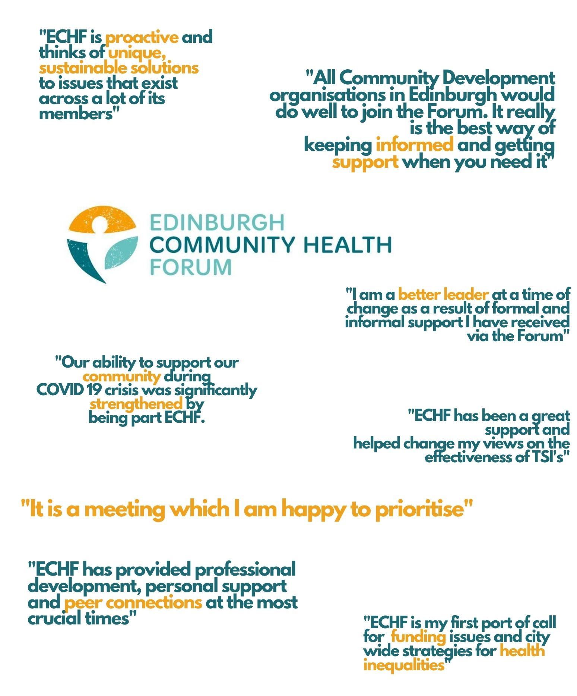
Charity Trustees Report and Accounts
31st March 2020

Charity Trustees Report

Form and purpose of the charity

Lothian Community Health Initiatives’ Forum (SCIO Charity # SCO23808) was founded by a constitution dated 16th April 2014. On 28th August 2019, its name changed to Edinburgh Community Health Forum. The organisation has been recognised as a Scottish Charitable Incorporated Organisation (SCIO) by OSCR and is generally exempt from taxation.

The charity’s main objective is to advance education and community development and to preserve and protect the good health of the people living in Edinburgh by bringing together in association community based health initiatives.
Membership is open to any individual aged 18 and over responsible for an organisation in Edinburgh which has clientele status and whose main objectives are the advancement of health using a community development approach.
The members elect the Board of Charity Trustees at every annual meeting. They administer the charity. Its principle address is Canaan Park, Astley Ainslie Hospital, 133 Grange Road, Edinburgh, EH9 2HL. The charity trustees are Charlie Cumming, Maruska Greenwood, Marion Findlay and Catriona Windle. The day to day running of the Forum is delegated to its strategic development manager, Stephanie-Anne Harris.
As a SCIO the members have no liability for the debts of the organisation.

Chairpersons Message
The Forum continues to go from strength to strength under the management of Stephanie-Anne and Grace who have both continued to embrace their work with enthusiasm and commitment. Stephanie-Anne continues to be a member of the IJB’s Strategic Planning Group and this year has led the working group to develop a funding process for the IJB's Innovation Fund. This has been and will continue to be, a huge amount of work, but keeps Forum members up to date with a good understanding of any changes ahead.
The role of the Forum continues to be crucial as maintaining and strengthening at strategic level is vitally important to the services being delivered by the Forum members. Our partnership work with EVOC has increased and I now represent the Forum on their 3rd Sector interface Group, with support from Stephanie-Anne. I would like to take this opportunity of thanking Suzanne Lowden, Sarah Bryson and Liz Simpson; all of whom continue to support Forum members and advocate for addressing health inequalities across the city. We would like to thank once more NHS Lothian and Edinburgh Health and Social Care partnership for their ongoing support.
Edinburgh Community Health Forum remains in sound financial shape with no significant liabilities and a healthy reserve at March 31st 2020.

Review of activities
The year 19/20 was the first year of the 3-year funding received from Edinburgh's Health and Social Care Partnership. The year has seen a growth in our membership from 36 organisations to 44. Business as usual has seen the Forum continue to meet on a monthly basis to discuss issues of concerns as well as hearing from a variety of guest speakers. Instead of the annual training programme, this year saw the introduction of action learning sets for members to join and to really focus on the issues affecting members as managers and leaders in the 3rd sector; these sessions have been delivered on the Forum's behalf by Duncan Wallace. In addition, several members co-designed with Duncan Wallace a bespoke 3 day leadership/managing change programme which was very well received and attended by forum members over the winter months.
Over the summer months, Stephanie-Anne led a working group on behalf of Edinburgh's IJB to develop a grant process for the IJB's innovation fund. The process was subsequently agreed by the IJB and during December a series of 'Dragons Den' type meetings were held in order to determine which organisations should receive the innovation funding. Unfortunately the impact of Covid has postponed the implementation and delivery of the exciting projects that were successful in receiving the innovation funding.
Our work with ‘A Matter of Focus’ on developing a new evaluation framework for both the forum and its member organisations continues, and we now have more than 10 organisations actively involved.
Social media through the Forum’s website, Facebook and Twitter continues to be important to the Forum in promoting its work.
Work at locality level continues to be developed with Grace in particular attending locality meetings and meeting regularly with members to provide support.

Accounts
The charity trustees submit the accounts for the year ended 31st March 2020. The comparative figures cover the year ended 31st March 2019.The results are as set out in the accounts
The Charity Trustees consider the financial position of the SCIO to be satisfactory. The results are set out in the accounts. It is the policy to retain at least 3 months expenditure as unrestricted reserves. The aim was achieved at 31st March 2020.
The charity received a grant of £7,058 relating to 2018/19 after 31st March 2019.
During the year a grant was received from EHSCP to fund general costs. This grant is held in a restricted fund. A deficit was incurred and so a transfer to cover this was made from unrestricted funds.
During the year a further grant was received for training and business development; money was spent and the balance carried forward in a restricted fund.

Independent Examiner
The Trustees have appointed Mr AW Scotland as Independent Examiner. A resolution to reappoint him will be put to the Annual General meeting.
Independent Examiner’s Report Edinburgh Community Health Forum (SCIO) on the accounts of the charity for the year ended 31st March 2020 set out in pages 4 to 6.
Respective Responsibilities of the Trustees and Examiner
The Charity trustees are responsible for the preparation of the accounts in accordance with the terms of the Charities and Trustee Investment (Scotland) 2005 Act and the Charities Account (Scotland) Regulations 2006. The Charity trustees consider that the audit requirements of Regulation 10(1) (a) to (c) of the Accounts Regulations does not apply. It is my responsibility to examine the accounts as required under section 44(1) (c) of the Act and to state whether particular matters have come to my attention.
Basis of Independent Examiner’s Statement
My examination is carried out in accordance with Regulation 11 of the Charities Accounts (Scotland) Regulations 2006. An examination includes a review of the accounting records kept by the charity and a comparison of the accounts presented with those records. It also includes consideration of any unusual items or disclosures in the accounts and seeks explanations from the trustees concerning any such matters. The procedures undertaken do not provide all the evidence that would be required in an audit and, consequently, I do not express an audit opinion on the accounts.
Independent Examiner’s Statement
In the course of my examination, no matter has come to my attention
- Which gives me reasonable cause to believe that in any material respect the requirements:
  - to keep accounting records in accordance with section 44(1) (a) of the 2005 Act and Regulation 4 of the 2006 Accounts Regulations, and
  - to prepare accounts which accord with the accounting records and comply with Regulation 8 of the 2006 Accounts Regulation
have not been met or
- to which, in my opinion, attention should be drawn in order to enable a proper understanding of the accounts to be reached.

A.W. Scotland CA  10 Craighall Crescent  Edinburgh  EH6 4RY | Date: 24th August 2020  …………………………………………...

Income and expenditure account and statement of financial affairs for the year ended 31st March 2020
2019 | 2020 |  |  |  |  | 2020
Total | Income | Restricted EHSCP | Restricted NHS HP | Total Restricted | Unrestricted funds | Total
 | Grant: Edinburgh Health & Social Care Partnership | 49,438.20 |  | 49,438.20 |  | 49,438.20
 | Grant: NHS Lothian Core |  | 25,000.00 | 25,000.00 | 7,059.00 | 32,059.00
61,176.00 | Total Incoming Resources | 49,438.20 | 25,000.00 | 74,438.20 | 7,059.00 | 81,417.20
Total | Expenditure | Restricted EHSCP | Restricted NHS HP | Total Restricted | Unrestricted funds | Total
31,501.30 | Employment costs, Salaries | 34,259.53 |  | 34,259.53 |  | 34,259.53
1,891.44 | Pension | 2,007.68 |  | 2,007.68 |  | 2,007.68
232.8 | Salary processing charges | 255.12 |  | 255.12 |  | 255.12
33,625.54 |  |  |  | 36,522.33 |  | 36,522.33
1,890.77 | Travel and function expenses | 534.20 |  | 534.20 |  | 534.20
402.96 | Insurance | 407.28 |  | 407.28 |  | 407.28
4275.25 | Workshops and training |  | 14,837.87 | 14837.87 |  | 14,837.87
7,440.00 | Evaluation Framework Development | 11,999.40 |  | 11999.4 |  | 11,999.40
5,070.00 | Website | 294.23 |  | 294.23 |  | 294.23
612.28 | Office expenses and equipment | 1,033.42 |  | 1033.42 |  | 1,033.42
53,316.80 |  | 50,790.86 | 14,837.87 | 65,628.73 |  | 65,628.73
200 | Fees of the Independent Examiner | 200.00 |  | 200.00 |  | 200.00
53516.8 | Total resources expended | 50,990.86 | 14,837.87 | 65,828.73 | 0.00 | 65,828.73
7,659.20 | Surplus/(deficit) of income over expenditure for year | -1,552.66 | 10,162.13 | 8,609.47 | 7,059.00 | 15,668.47
 | Transfers | 1552.66 |  | 1,552.66 | -1,552.66
7,659.20 | Surplus of Income and expenditure for the year after transfer | - | 10,162.13 | 10,162.13 | 5,506.34 | 15,668.47
 | Funds brought forward | - | 14,147.14 | 14,147.14 | 45,957.83 | 60,104.97
 | Funds carried forward at 31st March 2020 | - | 24,309.27 | 24,309.27 | 51,464.17 | 75,773.44

Balance Sheet as at 31st March 2020
2019 |  | 2020
60,304.97 | Current assets (Bank) | 75,973.34
200.00 | Less current liabilities (creditors, amounts falling due within one year, accruals) | 200.00
60,104.97 |  | 75,773.34
 | Represented by:
45,957.83 | Unrestricted funds | 51,464.17
14,147.14 | Restricted funds | 24.309.17
60,104.97 |  | 75,773.34

These accounts were approved by the Executive Committee on 24th August 2020 and signed on behalf by:

____________________________________________________________________________________
Notes to the Accounts
Accounting Convention
The accounts are prepared under the historical cost convention.
Accounting Policies
The Accounts are prepared in accordance with Statement of Recommended Practice Number 2 – Accounting for Charities, effective January 2015 and the Financial Reporting Standard for Smaller Enterprises (effective 2015). No separate Statement of Financial Activities has been prepared as this is the same as the Income and Expenditure account.
Income is credited as it is received. Expenditure is changed as it is incurred. A separate grant has been received to provide training and it is held in a restricted fund.
Executive Committee Members and Employees
The Executive Committee Members received no remuneration during the period. There was an average of two employees during the year. No Executive Committee member was reimbursed for travel expenses. Contributions to personal pension schemes were made during the period on behalf of 2 employees.
Period of Accounts
The accounts cover the year ended 31st March 2020. The comparative figures cover the year ended 31st March 2019.
Funds
During the year a grant was received from EHSCP to fund general costs. This grant is held in a restricted fund. A deficit was incurred and so a transfer to cover this was made from unrestricted funds.
A grant for training and support hours has been received by the charity during previous years, money has been spent and the balance carried forward in a restricted fund.
A grant for 2018/19 for unrestricted funds of £7,059 was not received until after 31st March 2019.

