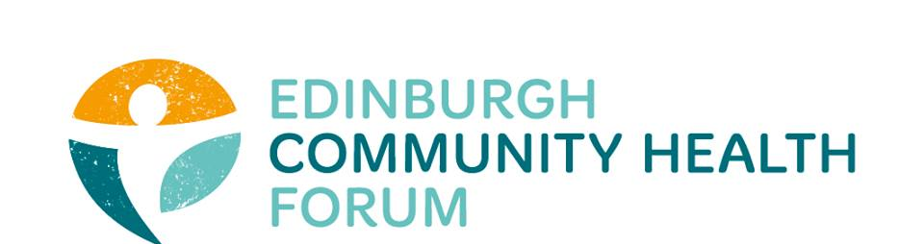
AGM
26th August 2019
New Register Dome House, Edinburgh

Attendees: Brenda Black (Edinburgh Community Food), Suzanne Campbell (The Junction), Helena Richards (Carr Gomm), Anne Munro (Pilmeny Development Project), Dawn Anderson (Pilton Community Health Project), Helen Scammell (Pilton Community Health Project), Julie Tickle (CEC), Suzanne Lowden (CEC), Anna Templeton (Dr Bells Family Centre), Brock Lueck (One Parent Families Scotland), John Halliday (Community Renewal), Liz Simpson (NHS Lothian), Rossi Craig (The Health Agency), Dermot Gorman (NHS Lothian), Amanda Hunter (Health in Mind), Linda Arthur (The Health Agency), Biddy Kelly (Fresh Start), Magda Czarnecka (Feniks), Ruth Maclennan (Care4Carers), Stephanie-Anne Harris and Grace Mackenzie (ECHF).
Board of Trustees: Catriona Windle (Health all Round), Maruska Greenwood (LGBT Health and Wellbeing), Charlie Cumming (ELGT), Marion Findlay (Volunteer Edinburgh).
Guest Speakers: Margaret Hannah (International Futures Forum / SHINE Fife Council), Susan Paxton (Scottish Community Development Council / Community Health Exchange)
- Welcome and introductions.
Maruska Greenwood welcomed all and gave a brief introduction to our guests from City of Edinburgh Council, NHS Lothian and to our speakers. Dr Margaret Hannah will talk about her Three Horizons approach within the healthcare setting whilst Susan Paxton will give us a National Overview of Community Development work.
- Dr Margaret Hannah – Humanising Healthcare
During an engaging and thought provoking session, Dr Hannah contrasted the continually increasing demand on Health and Social Care systems, took stock on what restructuring and efficiencies have been made since c. 2015 and looked forward with the knowledge that there has to be more collaboration and cooperation with the third sector in order to remain successful.
She talked through the SHINE work undertaken in 2009 using the model for winter care services in Fife; which uses a personal outcome approach. There is an acknowledgement that the hospital is not the sole ‘community’ by which to interact with a patient. There can be great strides made in decommissioning as well as commissioning services where alternative solutions can be found. For example, there is huge value in enabling an older patient to be able to cook simple meals again (thrive), rather than a meals on wheels service (survive); which can strip them of their abilities and confidence in themselves.
Dr Hannah’s slides from the day can be found on the website here.
- AGM business

- Independent Examiner Sandy Scotland took us through the ECHF accounts. These demonstrate no liabilities and healthy reserves of 60,104.97, of which restricted, totals £14,147.14.
- The motion to use Sandy Scotland as our independent examiner was nominated by Catriona Windle and seconded by Linda Arthur.
- The 2018 AGM minutes were approved by Charlie Cumming and seconded by Suzanne Campbell.
- The 2018/19 accounts were approved by Catriona Windle and seconded by Linda Arthur.

- Summary of Activities 2018/19
Stephanie-Anne gave a summary of the work carried out over the past year. The EIJB grant review process was one which we were heavily involved in. We have been strengthening the role of community health by being more involved with EVOC as the Third Sector Interface and via SCDC / CHEX.
In terms of capacity building, the regular forum meetings provide monthly peer support and the recent work with a Matter of Focus has come a great way in bringing our collective stories together. We have offered bespoke training, leadership development in the new coaching partnership with Duncan Wallace and provided practical support day to day in terms or governance, policies and funding.
We have recently started Action Learning sets to great feedback and the next round will run from October. We continue to have a social media presence with blogs and visits to members.
The board of trustees has been steady for a number of years but this past year saw changes in the stepping down of treasurer Fiona Cross and Chairperson Iain Stewart. We are therefore pleased to announce some new members to the board:
- Catriona Windle replaces Iain Stewart as Chairperson; nominated by Charlie Cumming and seconded by Maruska Greenwood
- Charlie Cumming replaces Fiona Cross as Treasurer; nominated by Maruska Greenwood and seconded by Marion Findlay
- Marion Findlay joins the board as a trustee; nominated by Maruska Greenwood and seconded by Charlie Cumming.
Our work will continue to be guided by both the board and wider membership. Looking into 19/20 this will form work as part of the winter pressures group, leadership development and collective evaluation.
- A National Perspective of Community Work – Susan Paxton
There has been the recent appointment of Professor James McGoldrick as Shadow Chair of Public Health Scotland. He is a current convenor of the SSSC and board member of the Care Inspectorate and is a strong advocate for a whole system, community approach. The SCDC continually promote our work to Public Health Reform and proactively seek out opportunities to demonstrate how the sector can collaborate. The ECHF is a fantastic example of how we can aggregate together to tell the story of our work. Together we can scale up our impact.
- AOCB
None.
- Date of next meeting
Confirmed as 1st October 2019.

