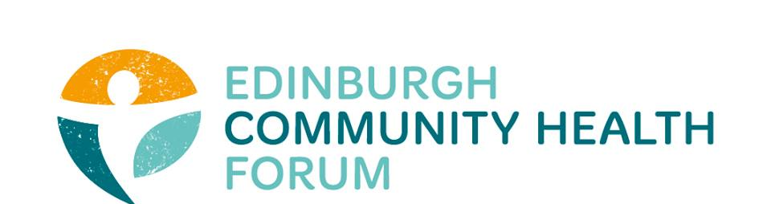
AGM
24th August 2020 via Zoom

Attendees: Brenda Black (Edinburgh Community Food), Suzanne Campbell (The Junction), Helena Richards (Carr Gomm), Suzanne Lowden (CEC), John Halliday (Community Renewal), Liz Simpson (NHS Lothian), Ian Brooke (EVOC), Ruth Maclennan (Care4Carers), Anne Munro (Pilmeny Development Project), Rosin Hurst (EVOC), Moyra Burns (NHS Health Promotion), Emma Cormack (The Health Agency), Kevin Rowe (HIV Scotland), Rachel Green (The Ripple), Alison McGhee (Health in Mind).
ECHF and Board of Trustees: Catriona Windle (Health all Round), Maruska Greenwood (LGBT Health and Wellbeing), Charlie Cumming (ELGT), Alex Perry, Stephanie-Anne Harris and Grace Mackenzie (ECHF).
Guest Speakers: Margaret Douglas (Edinburgh University / Public Health Scotland), Amy Grant (Matter of Focus), Sandy Scotland (Independent Examiner), Susan Paxton (Scottish Community Development Council / Community Health Exchange).
Apologies: Ailsa Cook (Matter of Focus), Brock Leuck (OPFS), Danielle Campbell (Dr Bells Family Centre), Dawn Anderson (PHCP), Marion Findlay (Volunteer Edinburgh), Biddy Kelly (Fresh Start).
- Welcome and introductions: Catriona Windle
Catriona welcomed everyone to our first virtual AGM. She drew everyone’s attention to the chat function for raising questions and where apologies, agenda, relevant documents were shared.

- Covid19 and Health Inequalities: Dr Margaret Douglas
Dr Douglas took us through some of her recent work on the impact on Covid-19 on health inequalities, which can be accessed in full here: https://www.echf.org.uk/dr-margaret-douglas-covid-and-health-inequalities/
Those in the most deprived areas were more likely to die, whilst there was also an increase seen within the Chinese population. Most of those people who had an underlying condition were more susceptible.
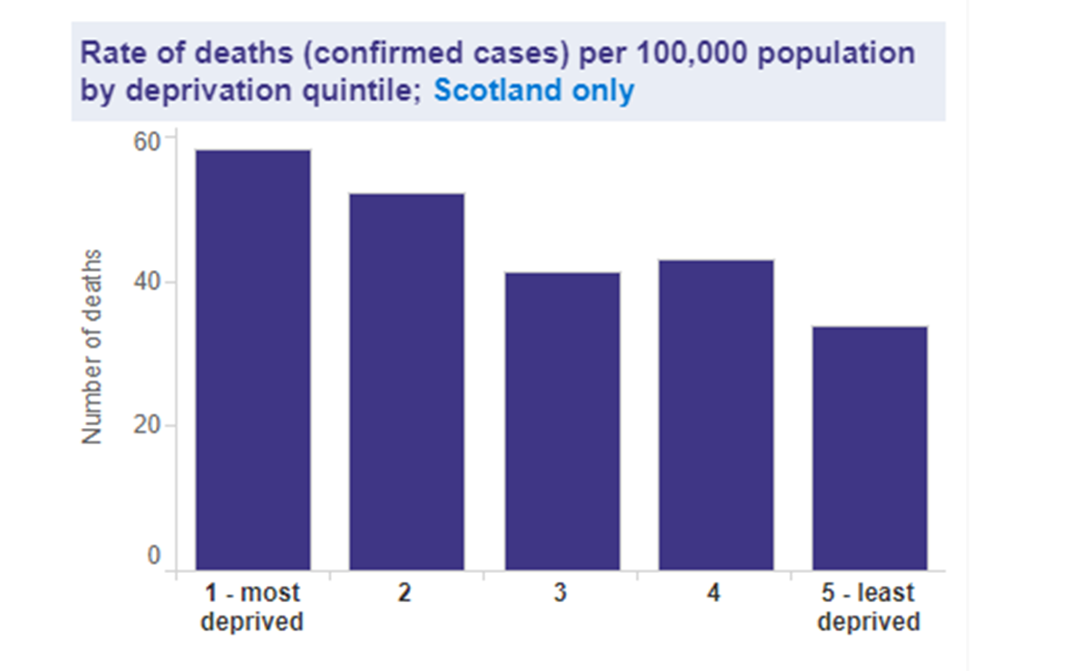
Frontline employment, overcrowded and / or intergeneration housing, language barriers and reliance on public transport all contribute to increased risk also. Unemployment has doubled and we know that the statistics show that there s a 76% chance of reduced mortality with 10 years out of work.
The effect of social distancing on health is also worthy of consideration. Dr Douglas drew attention to her publication in the bmj which show the closely related factors, directly and indirectly:
- Economic impacts such as workplace closures, childcare
- Mental health impacts such as social isolation, fear, anxiety
- Family impacts such as family violence, loss of education
- Health related behaviours
- Disruption to services
- Transport and greenspace
- Communities
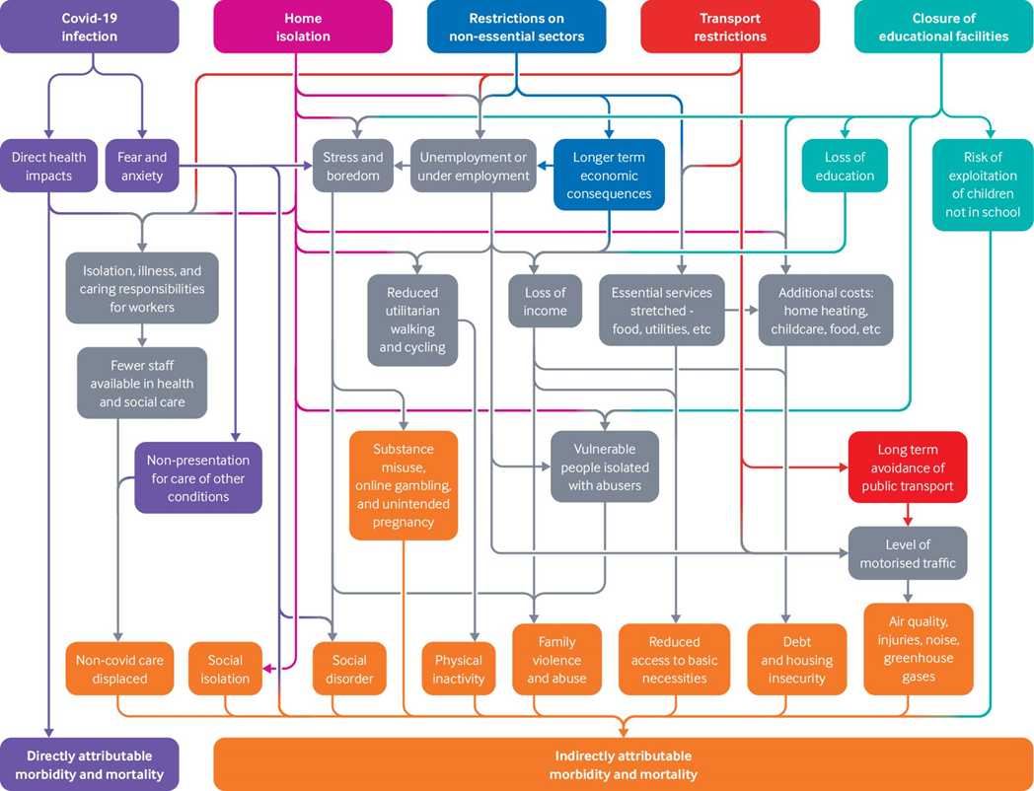
(Margaret Douglas et al. BMJ 2020;369:bmj.m1557)
Prior to March, there was already concerns on the effect of austerity and the inability of services to respond to the increases in inequality. Understandable when the virus first hit the focus was on the immediate control of the virus. Now we look to policy responses to help mitigate the longer term impact. What can we regain from the past six month?
Kevin Rowe (HIV Scotland): Thank you for that, Margaret. I was surprised to hear the figure of 4,000 COVID deaths in Scotland when the reported Scot Gov figure is under 2,500. Is that including excess deaths, deaths in care homes etc.?

Dr Margaret Douglas: Indeed, yes. I think the more accurate figure is that one. The discrepancy between the figures was due to the lack of testing in the early days of the pandemic.
John Halliday (Community Renewal: As community organisations we very quickly switched to crises mode. What is concerning is that a lot of the long term planning disappeared overnight (or seemed to).
DR MD: Yes, this is rightly a concern. All resources rightly had to be directed to the NHS to control the disease and everything else had to wait. We now need to strengthen services as it wasn’t possible to do both at that time. There is going to be a huge knock on effect to secondary services.
Brenda Black (Edinburgh Community Food): What has been a struggle for services is where contracts were not met by the statutory sector. As a third sector we did not shirk away from work; rather we stepped up. Others externally to us using covid as an excuse has left us a bigger role to do and takes away from the frontline services we provide.

- AGM business: Catriona Windle
Independent Examiner Sandy Scotland detailed the ECHF accounts which demonstrate no liabilities and healthy reserves of £75,773.34. There was one clarification sought of headings raised on behalf of our funder which the board has taken away to rectify. This change will be reconsidered by the board of trustees on or before 22nd September however the accounts themselves were considered as approved. These can be found on the website here: https://www.echf.org.uk/echf-19-20-annual-report-and-accounts/
The motion to use Sandy Scotland as our independent examiner was nominated by Catriona Windle and seconded by Maruska Greenwood. 2019 AGM minutes were approved by Catriona Windle and seconded by Charlie Cumming. All current board members stood down and were re-elected as follows:
- Marion Findlay nominated by Maruska Greenwood / seconded by Catriona Windle
- Maruska Greenwood nominated by Catriona Windle / Seconded by Brenda Black
- Catriona Windle (Chair) nominated by Maruska Greenwood / seconded by Brenda Black
- Charlie Cumming (Treasurer) nominated by Maruska Greenwood /seconded by Helena Richards
Note was made to the vacant positions on the board; anyone interested should contact Catriona or Stephanie-Anne if interested.
- Collective Covid19 ECHF Evaluation: Alex Perry and Amy Grant
As we all know, back in March there was a huge shift in how we needed to look at services. There was a balance required in the risk of spreading the virus vs. the risk to our communities of not doing anything. It was difficult to plan ahead and there was the added burden of income loss whilst trying to generate new funding. We spent time interviewing ECHF members to find out how you adapted to the challenges; which included a huge shift to utilising online spaces and a great deal of creativity. The report focusses on two pathways:
- Supporting People Experiencing Health Inequalities During Covid-19 (example below)
- Partnership and strategic working during COVID-19
The full report will be available shortly and we would welcome any suggestions you have for how best to promote this work. We will add an agenda item to the next ECHF meeting in October. Thank you to everyone who has contributed to this work.

Supporting people experiencing health inequalities during COVID-19

What we do | Who with | How they feel | What they learn and gain | What they do differently | What difference does this make?
Contribute to emergency response work | People experiencing health inequalities and their community | Supported | Social connections via an online community | Engage with and participate in online support | The negative impacts of Covid on individual wellbeing and broader health inequalities are reduced
Provide formal and informal online support and communicate in a meaningful way |  | Included and part of the community | Practical and emotional support and resources | People take care of themselves and avoid risks of covid-19
Share information and resources online via the phone, email or post |  | 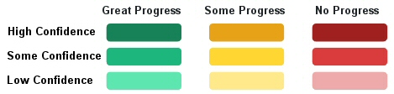

- A National Perspective of Community Work – Susan Paxton
In terms of what is happening nationally, the new Public Health Scotland body was formed in April. Of course, most of their work thus far has been towards the Covid reponse but we see already that high-level strategy work coming through has a strong emphasis on inequalities work. We will continue to promote the value of community based work, in particular in accessing those ‘harder to reach’ communities. We should see more detail soon on the transformation plan (which looks to the poor HSC outcomes) and that this is a responsive piece of work.
About funding; SCDC/ CHEX disseminated emergency funds on behalf of the Scottish Government’s Supporting Communities Fund quickly. It was a light touch process. There are a group of funders now looking to the recovery phase (including Corra, The National Lottery). There will be a single portal to apply over 4-6 weeks. Please sign up to the CHEX Snippets mailing list to get up to date information on that.
Brenda Black (Edinburgh Community Food): We were grateful to the SCF as it helped us to react quickly.
Catriona Windle (Health all Round): It was a great process; simple and based on trust, It is reassuring to think that might become more normal going forward.
- The year ahead for ECHF: Stephanie-Anne Harris and Grace Mackenzie
Firstly, a chance to say thank you to our funders, board and membership for a great year. We have the results from our survey, which Grace will send out in full in the next newsletter but a snapshot is here:
What we are best at:
- Communication
- Championing Health Inequalities
- Networking
- Peer Support
- Professional Development
Going forward, what areas might you want help with?
- Funding Diversification
- Visibility
- Networking
- Evaluation
- Policy Development

The survey results will be used for our own evaluation and to plan work over the coming year including:

- How to provide support to members during and post Covid
- Forum wide evaluation
- A coordinated approach to training – Action learning sets, coaching, supervision
- Ongoing work with EVOC including Community Investment Strategy
- Core Grants – what will happen next?
- Continue to raise our profile
We have also used the opportunity to add some quotes will be added to our website and to the cover of our annual report here.

- AOCB
John Halliday (Community Renewal): As part of the city prevention strategy I'm looking at a piece of work around self-employment support for the massive cohort of recently redundant people. If you are starting anything like that, then please give me a shout.

- Date of next meeting: Tuesday 6th October 2020 at 9.15am

