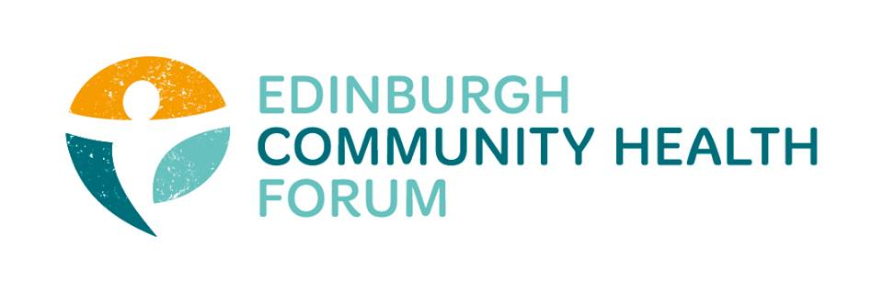
ECHF Forum Meeting
Tuesday 5th February 2019
LGBT Health and Wellbeing

Attendees: Iain Stewart (ECF), Maruska Greenwood (LGBT Health), Charlie Cumming (ELGT), Linda Arthur (The Health Agency), Stephanie-Anne Harris (ECHF), Mitra Rostami (Bright Choices), Alison McGhee (Health in Mind), Suzanne Campbell (The Junction), Magda Czarnecka (Feniks), Rachel Green (The Ripple Project).
Guests: Ailsa Cook, Amy Grant (Matter of Focus)
Apologies: Marion Findlay (Volunteer Edinburgh), Biddy Kelly (Fresh Start), Anne Munro (Pilmeny Development Project), Catriona Windle (Health all Round), Ruth Maclennan (Care4Carers), Michelle Reilly (Streetfit), Anna Templeton (Dr Bells Family Centre), Grace Mackenzie (ECHF), Moyra Burns (NHS Health Promotion).
- Welcome and Introductions – chaired by Iain Stewart

Iain welcomed everyone to the first forum meeting of 2019 and in particular to Rachel Green who has replaced Fiona Cross as manager of the Ripple. Iain noted that Jen Richards has moved from Pilton Community Health Project to Broomhouse Health Strategy Group and will start her new post on 25th February. Laura Plumb is now working for EVOC. Minutes from the last meeting were agreed and approved.

- Edinburgh Community Health Forum Update
Stephanie-Anne gave a brief personal overview of her experience of the IJB grant process; as an applicant, a member of the Steering Group and chair of one of the evaluation panels. She believed that the Forum’s application was successful due to the work done with Matter of Focus, in really examining the outcomes being delivered by the work of the Forum and being able to tell the Forum’s story through the use of Outcome Maps.

The Steering Group has still to meet to do a formal ‘lessons learned’ exercise. Stephanie-Anne asked that Forum members consider what they thought worked or didn’t work about the process and email any views to Stephanie-Anne, including any ideas they had for changing/improving the process which she would collate into a feedback report from the Forum, with any individual comments anonymised.

Currently, feedback is being given to those organisations who were unsuccessful in the application process, including scores and general pointers. One member of the Forum confirmed that this had been a helpful session.

It was acknowledged that the lack of clarity over the HIF at the time of the submission of the grant applications had not been at all helpful, although Moyra Burns did make an apology for this at our December meeting.

Stephanie-Anne presented a brief summary of the work of the Forum for the next 3 years which can be found here. She highlighted the forthcoming Forum open morning/drop in session to which organisations receiving IJB funding have been invited.

A focus for the next 3 years will be on a training programme, evaluation and research. In relation to training, S-A reminded everyone that there were still a couple of places available on the action learning so please get in touch if you wish to take part in this ASAP.

Finally S-A highlighted the current budget situation affecting the IJB and recommended that members read the IJB papers: http://www.edinburgh.gov.uk/meetings/meeting/4639/edinburgh_integration_joint_board#minutesDateSearchWidget

- Matter of Focus – Ailsa Cook
Ailsa gave an overview of Matter of Focus (www.matter-of-focus.com) and also a helpful description of programme, population and personal outcomes. A recent presentation can be seen here.

She reminded members of the work already done by Iain, Grace and S-A H to develop Outcome pathways for the Forum using Outcome Navigator. The 2 main pathways used are:
- Supporting Forum Members
- Strategic Influencing.

There was good discussion on pathways and evidence for a wider Forum approach to include member work. The group used headings to develop pathways for:
- Supporting People
- Community Capacity Building
As it was agreed that these could be generic to all members. Ailsa will write up these 2 pathways and work with Grace, S-A and any other members who would be keen to use Outcome Navigator for evaluation of their own programme / projects. The Forum has budget for members to use this tool. A further meeting will be held to develop the generic pathways so please look out for this or contact S-A H for further discussion.

- AOCB
Magda Czarnecka of Feniks reported that she had recently submitted a grant application to the Home Office for awareness raising with communities affected by Brexit under the ‘Settlement Status.”

Volunteer Edinburgh have hot desk space available (Leith Walk).

Contact Grace for any items to be included in the newsletter by the third week of each month. Items can be out on social media and the website at any time. Blog posts are very welcome.

- Future Meetings
Please remember that all meetings will now run 09.15-11.15, with a trustee meeting from 11.15-12.00. All dates for 2019 are on the website and papers will be uploaded here for each meeting.
Thursday 7th March – The Health Agency. Guest Speaker is Helen MacFarlane, Edinburgh Leisure. https://www.echf.org.uk/forum-meeting/march-forum-meeting/

Tuesday 2nd April – Venue TBC https://www.echf.org.uk/forum-meeting/april-forum-meeting/

