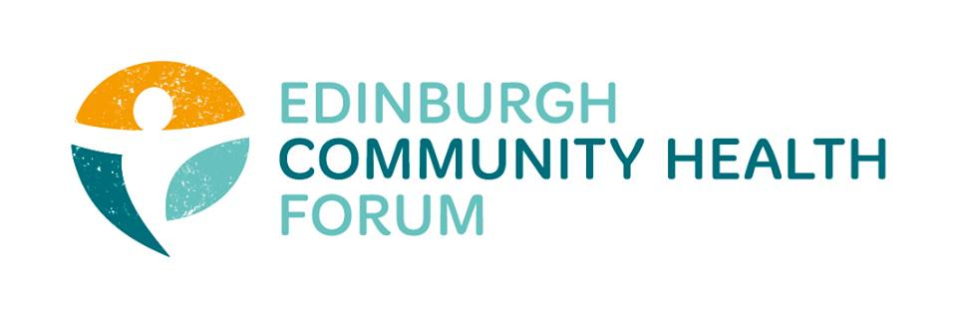
ECHF Forum Meeting
Tuesday 5th May via Zoom

Attendees: Stephanie-Anne Harris (ECHF), Grace Mackenzie (ECHF), Alex Perry (PCHP/ECHF), Ruth Maclennan (Care4Carers), Brock Lueck (OPFS), Anne Munro (Pilmeny Development Project), Catriona Windle (Health All Round), Maruska Greenwood (LGBT Health and Wellbeing), Nancy Bryson (Beacon Club), Magda Czarnecka (Feniks), Fiona Robertson (Headway), Jocelyn Lockhart (BHealthy Together), Valerie Clark (Harlaw Monday Group), Helena Richards (Carr Gomm), Dorothy Simpson (Currie Day Centre), Helen Scammell (Pilton CHP), Kevin Rowe (HIV Scotland), Charlie Cumming (ELGT), Brenda Black (ECF), Theodora Hidalgo (PEP), Su Millar (Lifecare), Grant McLay (Libertus).
Guests: Liz Simpson (NHS Lothian), Suzanne Lowden (CEC), Susan Paxton (SCDC / CHEX)
- Update from Stephanie-Anne Harris, ECHF
I have been involved with the Edinburgh Food Initiative working group with EVOC which is bedding in now. The contacts for each locality are:
North East: Kellie Mercer, Caring in Craigmillar, 0131 510 6930/07427 612792
South East: Peter Carruthers, SEAG. 0131 6693847. manager@seag.net.uk
South West: Bridie Ashrowan, SPACE/Broomhouse. bridie@spacescot.org
North West: Biddy Kelly, Freshstart. 07387 105200. biddy@freshstartweb.org.uk
ECHF has been successful in applying to the Supporting Communities Fund as an anchor organisation on behalf of members. Offer letters and payments should be made within the next week once funds are received.
Please remember that although you are all working full speed to deliver services, please remember there is such a rich amount of information to be gained for evaluation purposes e.g. how your service has had to transform / adapt / grow. Grace and I now have some extra resource on board (Alex Perry) who will be looking to bolster current evaluation and also specifically the COVID response. He is also able to help with small amounts of social media and infographs. Contact either of us and we will review the request and put you in touch. Please also remember that if you happen to have staff who are furloughed then as part of training the Matter of Focus team have weekly Outnav webinars each Thursday at 11am.
- Update from Susan Paxton, Scottish Community Development Council / CHEX
You will have no doubt seen the £40 million worth of funds being made available for COVID work and we have been involved in distributing some of that via the Supporting Communities Fund. Whilst there is some acknowledgement some of the process and streams are a bit messy, the emphasis was to get this mobilised as quickly as possible. So please bear with us. There will be another round of funding coming after this. We will need to start to look to how to stabilise the good work that has been initiated to meet community needs.
One great thing which has arising as a result of the pandemic is to legitimise how the community approach has proven its worth. There has inevitably been a priority to focus on inequalities; as we have had at the top of our agenda for years. There is an appreciation and acknowledgment that we are fleet of foot in order to be responsive.
In order to get the funds out quickly, there was not an onerous process nor will there be a complex paper trail. Rather it is built on trust and there is an appetite for this approach to be continued after the crises eases. With a particular hope that there will be a shift in how current spend is allocated i.e. to preventative / inequality work. We need to make sure to build back better and learn from the response.
- Member Update / Current Issues
Cat Windle, Health all Round: We are receiving more and more callers in emotional distress. We have been making use of the fantastic NHS stress control course and setting up an accompanying support group with zoom calls to make the best use of it. However, we are pushed for ideas on how to help with depression right now and would welcome any suggestions.
Su Millar, LifeCare: We are a registered service supporting help at home and have an issue with PPE, particularly masks. We are part of a twice weekly call with EVOC and CEC and understand that even the council are still having issues getting PPE..
Ruth Maclennan, Care4Carers: With no face masks available, there are organisations making face coverings. We have linked in with Magda Czarnecka (Feniks) to get numbers of these for now. However we have found that unpaid carers and carer support workers are able to get some help from the smart centre. If they are involved with personal care e.g. washing then PPE will be available; although yes there is a chronic shortage of medical grade masks right now.
Helen Scammell, Pilton Community Health Project: We are coordinating mental health and wellbeing support in the North as well as being involved in the food response. This will be a wrap around service from now until when restrictions are lifted. We have developed a leaflet to highlight what support is currently available to put in food packs. We all must be mindful that is it not possible to solely rely on social media.
Cat Windle: Does anyone have any ideas how we could tap into getting info out with prescriptions and housing associations? In order to distribute leaflets to some of the harder to reach audiences?
Brenda Black, Edinburgh Community Food: We have contacted Samaritans and have teabags and leaflets going in our boxes next week. We have had to push back on some leaflets which were due to go out from Public health as they had too much information and potentially difficult to read for e.g. sight affected. It is worthwhile to look at the ‘Living Life to the Full’ NHS resource: https://llttf.com/
There was a discussion surrounding Community Link Workers and if they are still referring? This varies across the city with some very busy and others not referring at all. There was a feeling that they should be helping with Community Health Organisations and Projects if not busy with referrals. Suzanne Lowden will take this feedback to Anne Crandles.
Anne Munro, Pilmeny Development Project: Some of you already spoke with regards to those not digitally connected. However it is clear through channels like the Children and Young People Forum that it is data poverty which is the problem, city wide. If a family has lost work and aren’t able to pay bills they won’t have access. We are seeing increasing numbers of single parents with increasing worrying mental health. They feel they have no support and are giving up on schooling now with a feeling it is getting worse and worse. We have examples of one ipad within a family of 4/5 children which makes stress so high. Many families are struggling with keeping a routine with the result that even getting them to answer the door in the afternoon is proving difficult since they are not long up.
Susan Paxton: I will take all of these points to the National forums to make sure they are aware.
Next meeting: Thursday 4th June, 9am.

