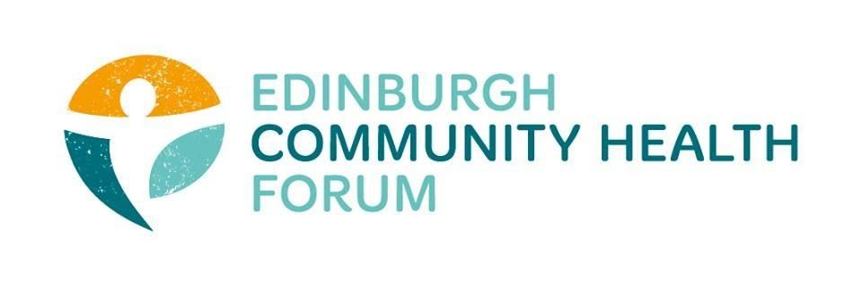
ECHF Forum Meeting Tuesday 6th October via Zoom

Chair:  Catriona Windle (Health all Round)  Attendees:  Grace Mackenzie (ECHF)  Alex Perry (PCHP/ECHF)  Stephanie-Anne Harris (ECHF)  Brenda Black (Edinburgh Community Food)  Brock Lueck (One Parent Families Scotland)  Marion Findlay (Volunteer Edinburgh)  Emma Cormack (The Health Agency)  Helena Richards (CarrGomm)  Charlie Cumming (ELGT) | Guests:  Nikki Slowey (Flexibility Works)  Pall Singh (Bethany Christian Trust)  Ailsa Cook (Matter of Focus)  Apologies:  Biddy Kelly (Fresh Start)  Alison McGhee (Health in Mind)  Anne Munro (Care for Carers)  Danielle Campbell (The Junction)  Dawn Anderson (Pilton CHP)  Kevin Rowe (HIV Scotland)  Magda Czarnecka (Feniks)

- Flexible Working - Nikki Slowey (Flexibility Works)
The events of the past few months have brought to light the importance of a flexible workplace. At the moment only about 15% of jobs mention flexibility, but this is a missed opportunity which might detract good applicants. However you approach flexibility, it needs to work for you and your organisation. Some ways to incorporate it are:
- Linking it to business strategy / objectives
- Ingraining it into the culture
- Leadership modelling flexibility
- Support managers to lead teams
- Communicate – tell people what is possible
- Listen to your staff - what do they want / need
The forum team will look into the possibility of a flexibility workshop for members.
- Passing the Baton - Pall Singh (Bethany Christian Trust)

Passing the Baton helps local churches run a befriending service to vulnerable, isolated and lonely people, transforming lives and building connection in Edinburgh. You can find a short video on their facebook page: https://www.facebook.com/BCTPTB/ . Referrals from across the city are welcomed.

- Collective Evaluation - Ailsa Cook (Matter of Focus)
The collective ECHF Covid work is being finalised and a foreword will be sought from Dr Margaret Douglas. There will be a programme of events to promote the work such as a webinar and sharing it on different media outlets as well as via CHEX / Susan Paxton. Any further suggestions of where the work might be promoted would be fantastic.

MOF have recruited a new member of staff – Catherine Rose – who will lead the next stage of the work and in setting up new members on Outnav with the support of Alex Perry (PCHP / ECHF)and Conor Black (MOF). Catherine to come along to the next meeting in November with an update.

- ECHF Update
The members survey results showed us what would be good to focus on over the coming year, but with the pandemic still at the forefront of everything we do, we will keep on asking what support you might need. The team are looking into a session on funding / fundraising.
As a start Stephanie-Anne will host two ‘watercooler chats’ where she will be available for an hour on zoom for anyone who may wish to drop in. We will also set up a MS Teams channel and trial this for the November meeting to see if that will allow access to some of our colleagues who aren’t able to use zoom. Grace to set up.
- Next meeting
Thursday 5th November, trialling MS teams, channel can be found here: https://teams.microsoft.com/l/team/19%3a2f8e4078c35545aa8ab06ce364ecdc7f%40thread.tacv2/conversations?groupId=033ac749-b1eb-4d41-bec0-91c616cb322e&tenantId=2833ef38-212b-47fc-a93a-3dd504038bf2

