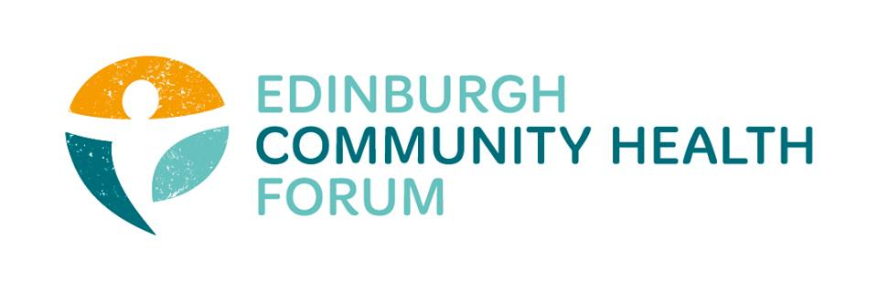
ECHF Forum Meeting
Tuesday 1st October 2019
Space: The Broomhouse Hub

Attendees: Kristin Armour (Caring in Craigmillar), Charlie Cumming (ELGT), Catriona Windle (Health all Round), Victor Chlebowski (Murrayfield Dementia Project), Helena Richards (Carr Gomm), Valerie Clark (Harlow Monday Group), Dorothy Simpson (Currie Day Centre), Nancy Bryson (Space), Linda Arthur (The Health Agency), Stephanie-Anne Harris (ECHF), Grace Mackenzie (ECHF).
Guests: Ian Brooke (EVOC), Suzanne Lowden (CEC), Moyra Burns (NHS Health Promotion), Helene van der Ploeg (Space).
Apologies: Suzanne Campbell (The Junction), Ruth Maclennan (Care4Carers), Anne Munro (Pilmeny Development Project), Brenda Black (ECF), Biddy Kelly (Fresh Start), Brock Leuck (OPFS), Helen Tait (PEP), Helen Scammell (Pilton CHP), Jen Richards (B:Healthy Together), Marion Findlay (Volunteer Edinburgh), Michelle Reilly (Streetfit), Anna Templeton (Dr Bells Family Centre), Mitra Rostami (Bright Choices), Alison McGhee (Health in Mind), Maruska Greenwood (LGBT Health).
- Welcome and Introductions – chaired by Catriona Windle

Catriona welcomed everyone to the meeting, in particular the guests present from NHS Lothian, City of Edinburgh Council and EVOC.

- Space: The Broomhouse Hub
Helene van der Ploeg welcomed the group to the newly opened Broomhouse Hub. Having been ‘The Broomhouse Centre’ for almost 30 years it was decided to update the name. During the building works in 2018 they consulted with the local community and key stakeholders and drawing inspiration from these discussions it was decided that the charity will now be called ‘Space.’

Helene was kind enough to give the group a tour; within the building there is light and flexible spaces for eating, meeting and working (hot desks are available in addition to the Space staff office). There are meeting spaces which will cater for local community groups as well as corporate events to provide a welcome revenue stream.

- Public Health Update
Moyra Burns was in attendance to give an overview of some of the changes within Public Health Reform and how this might look nationally as well as at the Lothians level. You can find further information here on the Public Health Reform website.

Nationally, COSLA and the Scottish Government have been working together to create a new body which will come into effect from April 1st 2020 and will be known as Public Health Scotland. This will bring together NHS Health Scotland, ISD Scotland and Health Improvement Scotland; of which there are c. 1000 staff. There are fourteen Health Boards (and seven special boards e.g. the ambulance service) which will not be deconstructed. It is unclear at this point whether funding streams will be administered via the new body.

Within the Lothians, there are four Health and Social Care Partnerships: City of Edinburgh Council, East Lothian, Midlothian and West Lothian. Of which three only work within adult health. In general terms the work at a local level includes:
1 – Public protection e.g. vaccines or disease outbreaks
2 – Health Services e.g. acute hospital services
3 – Health Improvement / Health Promotion which we more commonly refer to as ‘wellbeing.’
The timescale of the review is that papers will be made available at the end of October, with a model being proposed from November.

In terms of the role of the Forum it is important to continue to be able to evidence our work at a community level so evaluation is key; in particular qualitative case studies which tell a compelling story of the impact of prevention.

- Winter Pressures
Stephanie-Anne is working with EVOC on a small scale winter pressures project to be piloted this year. During December to February in particular the NHS gets clogged up and members can identify with the dread of Ward 15 of the Western General Hospital having to be opened especially to cope with demand. In essence the project is looking into ways to work with community organisations to reduce preventable admissions and identify the needs of patients upon discharge to keep them healthy at home. Examples are: Phoneline who can carry out regular welfare checks, befriending or signposting.

- Innovation Fund
Members may remember that the innovation fund was put on hold whilst the transition funding work was carried out by the EIJB. S-A has resumed work on the fund which is for £300k over two years. The steering group met with Moira Pringle this week and it is envisaged that the fund will be open for applications imminently with a closing date of the end of October. As a reminder, this fund is aimed at the testing of new ideas and collaboration will be encouraged.

- Evaluation

There has been lots of feedback filtering through about the Outcome Navigator tool as we begin to see some traction within the current round of users. Grace has collated this to take to Matter of Focus later in the week. In particular feedback was that the webinars haven’t worked as well as hoped. There was discussion within the group of how to approach the use of the tool within each organisation i.e. whether to have one key person to use or to share with a wider group of users to input their specific data individually.

On the 23rd January, ECHF and Matter of Focus will host a show and tell event and welcome ideas as to which key stakeholders to invite along to this. Key members of the EIJB will be invited as a start.

Suzanne Lowden reminded everyone that the current EIJB HSC Grants SMAR evaluation was sent out in June by Sarah Bryson; she will arrange to resend.

- Community Link Work Commissioning
The proposed agenda item of the three conversations model had to be postponed due to technical difficulties so instead Ian Brooke of EVOC took the time to chat about the upcoming CLW commissioning events due to kick off this week:
North East: Thursday 3 Oct, 9.30 - 11am @ Hibs FC Conference Centre (Clubhouse), 12 Albion Pl, EH7 5QG
South West: Monday 7 Oct, 9.30 - 11am @ WHALE Arts Agency, 30 Westburn Grove, EH14 2SA
South East: Thursday 10 Oct, 9.30 - 11am @ Gilmerton Society Hall, 27 Drum St, EH17 8RQ
North West: Monday 14 Oct, 9.30 - 11am @ EVOC Offices, 525 Ferry Road, EH5 2FF
Each session will cover the same content.

- Future Meetings

Thursday November 7th CarrGomm, Harewood Road. Please remember that all meetings will now run 09.15-11.15, with a trustee meeting from 11.15-12.00. All dates for 2019 are on the website and papers will be uploaded for each meeting.

