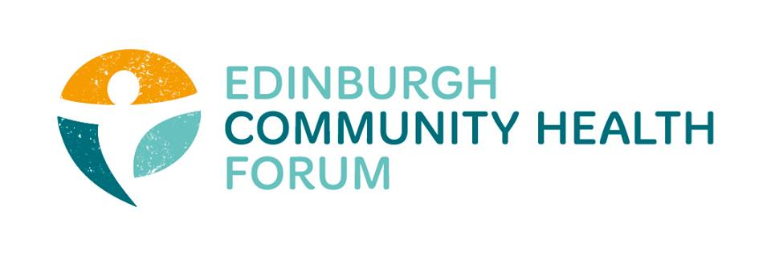
Thursday 7th November, Carr Gomm
11 Harewood Rd, Scotland, Edinburgh, Edinburgh, EH16 4NT

0915 - 0920 | Welcome, apologies, previous minutes | Catriona Windle (Chair)
0920 – 0950 | Health inequalities ethnicity case study research (based on ethnicity?  (Lena is collecting evidence for Research Excellence Framework (REF) impact case studies and how Edinburgh-led research by Raj Bhopal (SHELS study) may have had impact on practice in Scotland.) | Lena Lorenz (Edinburgh University)
0950 - 1020 | Settled Status  (EU nationals in order to maintain their right to remain in the UK after Brexit need to apply to the scheme. Service users might lose their eligibility to support, if they don't apply) | Dorota Peszkowska (Feniks)
1020 - 1050 | Supervision within the Forum | Catriona Windle (Chair)
1050 - 1100 | Innovation Fund | Stephanie-Anne Harris
1100 - 1115 | AOCB

Date of next meeting – 3rd December, Pilton Equalities Project

Apologies: Brock Lueck (OPFS), Ruth Maclennan (Care 4 Carers), Alison McGhee (Health in Mind), Anne Munro (Pilmeny Development Project), Valerie Clark (Harlaw Monday Group), Dorothy Simpson (Currie Day Centre).

