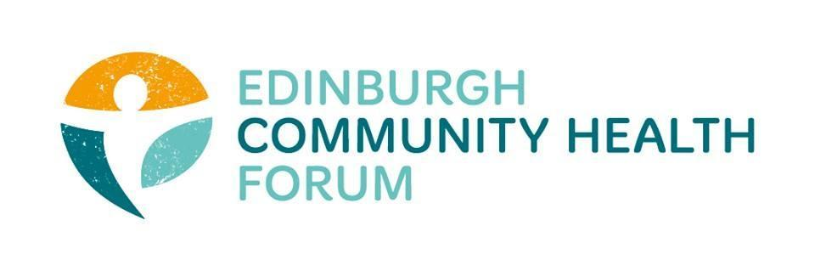
ECHF Forum Meeting
Date 02/11/21

Attendees: Stephanie-Anne Harris (ECHF), Magda Czarnecka (Feniks), Maruska Greenwood (LGBT), Susan Paxton (SCDC), Brenda Black (ECF), Charlie Cumming (ELGT), Brock Lueck (OPF), Alison McGhee (Health In Mind), Suzanne Lowden( H & SC P’Ship), Marion Findlay (Volunteer Edinburgh), Helena Richards (CarrGomm), Biddy Kelly (Fresh Start), John Halliday (Community Renewal), Fiona Partington (THA) Suzanne Campbell (The Junction),Anne Munro and Abbie( Pilmeny), Rossi Craig(THA), Carrie McAliden( the Welcoming),Mitra Rostami(ELREC)
Apologies: Kelly Innis (Four Square), Tesfu Gessesse (The Welcoming), Jen Richards( Bhealthytogether),Georgia Artus( LifeCare),Ruth McLellan ( Care4Carers)
- Welcome and Introductions - Cat

Cat welcomed everyone to the meeting.

- Mitra Rostami (ELREC)
Mitra Rostami gave a presentation on her work and the project ‘Open Arms’, which is National Lottery Funded. It is a Women Only project, focusing on improving both physical and mental health ( https://www.elrec.org.uk/services/open-arms/). Services include peer support, exercise classes, yoga and Pilates, arts and crafts, English classes. Of the women attending: 70% African/Sudanese, 15% Asian and middle eastern, 10% Polish and eastern European.
All were encouraged to refer women and get in contact with Mitra.
- The Pact
The next in the series of Pact meetings was held on 28th October, and was entitled : “ Talking about Transition”. Agenda items included: an update on the summer season conversations with presentations from Craigmillar Niddrie Festival and Pilton Community Health project; followed by workshops on possible solutions for accelerating solutions which form part of longer-term aspirations around community commissioning.
Members expressed some concerns about the Pact, it’s purpose and the outcomes for this work. Members were reminded that the Pact will develop ‘community commissioning’ that will distribute the monies from the former IJB grants scheme. Comments made by members included:
I don’t have time to engage in the Pact; too busy with service delivery
Enjoyed the recent session on solutions
Worried about the pace of the work, is it too fast? Have concerns that organisations may miss out if they don’t engage. Concerned that some organisations seem to have secured additional funding already.
Only given 2 projects to talk about; anted time to talk about more options and do some blue sky thinking, but the conversations were shut down
Liked the initial brainstorm session. Have some concerns about using the Adult Mental Health £ as a pilot for collaborative commissioning; seems very fast paced; is it set in stone somewhere?
Session was quite confused; seems that some people are operating in a parallel universe.
Appears that we are missing out focusing on inclusivity and accessibility; sessions are too fast; the session didn’t cover anything at all for B & ME communities who appear to be missing out.
The session were originally sold that you didn’t have to attend them all. Now it appears that you do. How organisations are currently funded is key to unlocking how we might do things differently. We need to be bold and brave and harness the positivity of working together as we did during Covid.
There is power in our network as a Forum; our focus should be on community mobilisation. Where are things at with community anchor networks? How might the Forum develop these?
Some organisations don’t need to get into community commissioning; they just need £ to continue to deliver their services. Can we identify which organisations are ‘infrastructure’ organisations?
It is everyone’s core funding that is on the table in the Pact work. Time is fast approaching when decisions will have to be made, but there is nor process yet. Progress is not being made in a linear way. Does it need to be refocused? Do we need to think about how we might innovate through core funding whilst maintaining the current infrastructure? We need clarity or we are in danger of losing a lot of it.
Should the Forum be more proactive? Could we come up with our own proposal now? We have innovated over the past 2 years, and we continue to develop blended models of service delivery. Everybody is exhausted.
Is the Pact a direct repeat of the Mental Health PSP of 6 years ago?
The next Pact meeting is on 14th November, then 14th December.
- Joint work with CHEX
One of the fundamentals of the Pact is the creation of community anchor organisations / networks and a move to community commissioning. Susan and Des Mc Cart of the Improvement Service would like to support the forum in discussing what community anchor networks should look like and look at the work of Toby Low in terms of Human Learning Systems. The meeting held on 13th October, attended by several Forum members took a deep dive into these areas, with a view to trying to develop a blueprint collaboratively to have a better infrastructure for health and wellbeing. Discussions focused on: what is the problem we are trying to solve or issue we are trying to address (something at a reasonable scale but is doable); what is the scale of the issue/problem; is it local or city wide; who does it affect and how; what are the gaps that affect the problem or issue. A proforma has been circulated to all Forum members to be able to contribute their ideas to this and there will be a further meeting with Susan Paxton in early December.
- Digital Training with Ross McCulloch
The training sessions are continuing and have been very well received by those members who signed up. The next session is on 16/11. SAH has asked Ross to devise a follow up programme for 2022 which will include: social media, Service redesign and problem solving, involving ‘techy’ people on Boards. Further information to follow.
- Outnav
The outnav session on 18th of October was very poorly attended (i.e. no one!) . Members were reminded that these sessions are now being facilitated by SAH but members can still attend the weekly sessions held by Outman.

- National Care Service Consultation
At the last meeting of the Forum, members were of the view that they would like to submit a joint response as a forum. However, with Katie leaving, SAH has just not had the capacity to be able to coordinate a response.

- Minutes
The minutes of the previous meeting were approved.

- Date of next meetings
November 18th The Pact at 9.30
November 22nd Outnav 10.00am -12 noon
December 7th Forum meeting at 9.30
December 14th The Pact at 9.30

