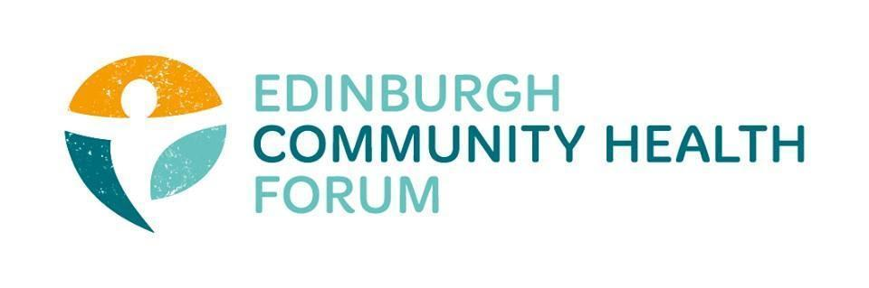
ECHF Forum Meeting
Date 01/02/2022

Attendees: Stephanie-Anne Harris (ECHF), Daniel Richards (ECHF), Rossi Craig (THA), Catriona Windle (HAR), Alison McGhee (HIM), Hayley Chandler (HIM), Anne Munro (PDP), Brock Lueck (OPFS), Brenda Black (Edinburgh Community Food), Fiona Partington (THA), Helena Richards (CarrGomm), Jen Richards (B Healthy Together) , John Halliday (CRT), Kelly (Four Square), Magda Czarnecka (Feniks), Marion Findlay (Volunteer Edinbrugh), Naomi Potts (Lifecare), Rachel Green (The Ripple), Ruth MacLennan (Care4Carers), Susan Paxton (SCDC), Suzanne Lowden ( H&SCP’ship), Dawn Anderson (PCHP)

Welcome and Introductions - Cat

Cat welcomed everyone to the meeting.

- Hayley Chandler: Health in Mind

Hayley from Health in Mind gave a short presentation on Peer community, what their role is and their
current goals.
Role- Support a network for peer support groups helping to enable people with lived experience of mental health challenges and recovery to use their experiences to accompany others through their recovery.
Goals for the future- Focus on Development in the community, providing workshops and other training experiences. Work with other organisations to expand the current partnerships:
- Building awareness and understanding of peer practice

- Challenging stigma surrounding mental health challenges and lived experience
- Promoting accessibility in peer spaces
Hayley also informed us of a 5 week training course (5- 3 hour sessions over 5 weeks) that are available for people looking to work as a peer
Hayley would also like to invite you to the third Gathering Peer Voices. This event is open to Edinburgh's Peer Workers, Peer Volunteers and all people interested in mental health, recovery & lived experience, who would like to learn about and contribute their views on how we can strengthen peer practice and improve mental health support in Edinburgh. It takes place on Wednesday 16 March 10am-1pm. It will primarily be over Zoom, however there will also be options to join using Teams.
Sign up at this link: https://www.eventbrite.co.uk/e/gathering-peer-voices-louder-than-words-tickets-260164538137
Or contact peer@health-in-mind.org.uk.

- The Pact
S-AH gave a summary of what the Pact is and the issues that have been discussed and that are still of concern regarding the Pact.
Very similar issues that have been raised previously are still prevalent with this topic and a summary of them include:
- Re the Collaboration request for funding expression of interest, It is unsure where the funding is coming from, how much is left and whether or not this could be taken from current core funding in the future.There is anxiety that applying for this funding now could later negatively impact future core funding of the organisations- this is something that needs to be clarified properly.

- There is a concern about 2 aspects relating to time
1. Many members feel as though there is still very little measurable progress being made when the pact is being discussed and as in the past the same issues and discussions are being had
2. The amount of time and energy being expended on solving these problems do not reflect the level of funding currently being offered by the Pact especially when considering it may not even be suitable for all organisations and may negatively impact core services at a later date.

- Uncertainty in terms of what the funding can even be used for- Is it primarily for innovative new ideas and projects or is this something that could be used to fund core services, fund existing ones or even expand existing ones.

- Overall the entire process has been very confusing and has shifted focus away from actually providing vital services and put towards trying to understand unnecessarily complicated applications. Organisations have a very limited amount of staff hours, applications are time consuming enough as it is without all these additional worries and things to try and figure out.
Potential action that could be taken
Formal Letter
It was suggested that a formal letter be sent by the ECHF on behalf of (and signed by) the member organisations to help clarify some of these issues. The exact contents would have to be discussed further however the general idea would be to try and address some of these specific issues and concerns and get a written response. This was a popular suggestion amongst present members.
-Several points were made in regards to this idea including
- Potential to take these issues higher up to apply pressure in order to get a response/ show that the current state isn’t acceptable
- Making sure that we stayed diplomatic with any communication towards The Pact
- It was suggested that rather than just critiquing or asking for clarification we could also include potential solutions and ideas for these issues, ensuring that we are being positive and forward thinking with our approach.
-There is a definite strength in presenting a unified front as this allows us to use our collective voice and strength to push for real change. Furthermore it stops individual organisations from being picked on or pushed out.
Single grant application through the ECHF
S-A suggested that like for the emergency covid response fund, the ECHF could put in a single bid for the collaborations monies and then, on a more trust based approach, divy this out between member organisations. While this does not necessarily fix all of the above mentioned issues, it may make the process simpler for each of the member organisations and allow them to focus more on providing their services and running the organisations.
This is also something that would need to be fully discussed and certain finer points would need to be worked out before this went ahead.
Some other general points that were made on this topic include
-If more extensions on the major grants go ahead, this severely limits organisations that do not currently have funding as they would be unable to apply for another year. This is an important point as core funding for organisations that do not currently have access also need to be considered.
-Bringing in EVOC and having discussions with them on the topic may be beneficial
-While community commissioning has its place, the entire £4 million ( former IJB Grants fund)should not be community commissioned

- Potential Roma project with Community Renewal
John Haliday from Community Renewal asked if any organisations would be interested in working with them on a project aimed at helping the Roma community in Edinburgh. He has asked me to circulate the following message:
There is an opportunity for small amounts of collaboration funding through Edinburgh PACT and I am exploring expanding a partnership collaboration which would more systematically look at supporting Roma across the city.

Community Renewal Trust have worked with over 3500 Roma since 2008 and now have a sister organisation, Rom Romeha, which is a separate Roma-led community development trust. However, none of this Roma work has been in Edinburgh to date (even though Edinburgh is where most of our staff deliver community services).

We know there are already other organisations who support some Roma families in Edinburgh or who know there are Roma families with unmet need for support. We don’t want to look at this issue alone and wondered if anyone wanted to collaborate further around this topic.

Drop me a line if this is of interest and we can discuss what might be done – we have until the end of February to respond, but we would always be interested in collaborating more generally too.
Email:john.halliday@communityrenewal.org.uk
- Joint work with CHEX
The next CHEX meeting is on Tuesday 8th February at 1.30pm
- OutNav Sessions
SAH and DR have met with Ailsa Cook from a Matter of Focus to look at training options for 2021/22. Now awaiting a full proposal from Ailsa
- AOCB
Suzanne Lowden is preparing letters for the IJB funded organisations with the amount they have been awarded for 2022/23, along with confirmation of a 3% inflationary uplift.

- Minutes
The minutes of the previous meeting were approved.

- Date of next meeting
March 3rd 2022 9.30am- 11am on Zoom

