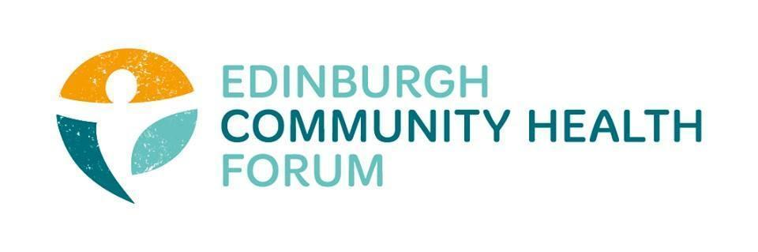Forum Meeting 05/04/2022

Attendees: Stephanie-Anne Harris (ECHF), Daniel Richards (ECHF), Charlie Cumming (ELGT), Nicola (Grapevine LciL), Alan Gray (HAR), Brock Lueck (OPFS), Dawn Anderson (PCHP), Georgia Artus (Vintage Vibes), Rossi Craig (THA), Biddy Kelly (Fresh Start), Brenda Black (ECF), Fiona Partington (THA), Helena Richards (CarrGomm), Jen Richards (B Healthy Together), Magda Czarnecka (Feniks), Richard Dark (ELGT), Rachel Green (The Ripple), Ruth MacLennan (Care4Carers), Sue Freeth (LifeCare Edinburgh), Susan Lancaster (LGBT H&W), Susan Paxton (SCDC), Suzanne Lowden ( H&SCP’ship), Linda Fitzpatrick (ECC),
Apologies: Catriona Windle (HAR), Anne Munro (PDP), Alison McGhee (HIM), Susan Lancaster (LGBTHealth),

- Welcome and Introductions:
Charlie welcomed everyone to the meeting and thanked Linda Irvine Fitzpatrick for returning to the forum in order to give an update on the PACT

- Update on the Pact from Linda Irvine FitzPatrick
Firstly we will be submitting our report for the stakeholder event on Friday.
We have also opened up a funding opportunity in time for the campaign on loneliness- hopefully the form is short and easy, we have been trying to take feedback on board from previous applications.
After today will get in touch with everyone who submitted a collaboration. There will be 22 who end up receiving funding. However I will also be sitting down to have a conversation with everyone.
IJB paper-19th April, will include a full update on the 7 recommendations from last year.
As of now the draft report contains a recommendation to extend current funding until 2025. This means all current funding will be carried over.
This is so that we can have a more successful public partnership around more good days and also have more time to craft the new funding application process.
While the paper in draft at the moment and could still change, there is support from the strategic planning committee for this extension.
I hope that this will allow us to be more flexible and respond to system pressures as they occur.

*The paper has been published (link below): https://democracy.edinburgh.gov.uk/documents/s46127/6.3%20The%20Edinburgh%20Wellbeing%20Pact%20-%20Formulation%20to%20Enactment%20Progress%20Report.pdf

- Questions and Answers on the Pact- All

Q) If there is going to be an extension on the health inequalities funding then how will this effect organisations that don’t currently have access to the funding? Is there going to be any opportunity for these organisations to apply/will there be new streams of funding that they may have access too?
The 4 mill is part of a bigger pot. If we look at it as a whole you can see that we have been putting some new money through to accelerate opportunities for funding streams and collaboration. There will be a chance for new collaboration and this added extension will provide a security for organisations relying on this core funding.
Response) It feels slightly unclear whether these new pots of money are offering that same security as that base level of funding that is currently available.

Q) You’ve already clarified how long the current grants but I just want to check that there won’t be any grant applications this year around.
There wont be a health inequalities grant process this year.
This is a way we can collaborate further, involving public sector while making funding streams more straightforward. Taken a long time to get through some of the governance processes
Q) While its great to hear about funding potentially getting extended, is there any chance of increasing the grant amounts, as we are already struggling in the current climate of increased cost of living burdens?
Current extensions will be within the current resource envelope. We are currently discussing how that would look out over the next 2 years. There won’t be any additional, for example 3% cost of living increase. First see if we can sustain that 3% and then look at other things

Q) With regard to the new loneliness fund, would it be a good idea to add slightly more time for the application?
Response) Timelines are very tight at the moment
We could add another week on but would be good if we could get it done before easter and the loneliness week as there will be a lot of attention on isolation.
Response) - I think a week extra would be helpful, as many people are currently on leave etc. just give people a little extra time
Charlie thanked Linda for updating everyone on the current situation of the PACT and for answering questions from forum members.

Discussion about the above answers is captured below.
One member said: I feel quite listened to about the issues raised about core funding. Might be a start of something quite exciting in terms of being able to collaborate. Allow us to be involved in being involved in how these processes are made. It’s important that we keep giving our feedback as it is clearly being listened to on some level.

Q) When will we know if the decision to extend funding has been made?
- During the meeting which you can watch live on the council website.
It might also be worth checking the paper once it’s been submitted to see if it actually has the recommendation included

Suzanne Lowden) If people who had experienced the mental health fund funding process wanted to, then it would be good to feed that back to Linda.
S-A H) Brought up the Plymouth pact and reiterated the idea of trying to set something similar up in Edinburgh. The extension would give us an opportunity to set some time aside and start thinking about what that might look like for Edinburgh.

- Update on Mental Health and Wellbeing Fund outcomes- All
Brenda- Felt like she had a poor experience as she spent 50+ hours on the first one and still hasn’t had any feedback despite the fact that the next one is starting very soon. Can’t go strong into a similar funding process when we don’t have any feedback on why we didn’t get the last one.
Brock- Having only a few weeks to “collaborate” isn’t true collaboration.
Rossi- even though we got the money it was still a lot of time invested. We also got told that we could have applied for more in the end.
Organizations that didn’t apply because they recognised that it wasn’t worth it wont be given a feedback card. So that is an issue that should be taken back to EVOC.
Helena- Wasn’t sent the feedback card- think it was because Carrgomm is too big and had to do a joint application, so only the organisation we applied with actually got one.
As a result feedback was not easy to give, just an open ended box on the website- not guided questions and hard to find. However it’s important that we do all give our feedback or nothing will improve for the next time around.
Maruska- At a meeting where the civil service gave presentation saying how good the process was. However this is not my experiences or the experiences of people I have talked to.
we put in application but decided that the meetings would be very time consuming and didn’t attend the meetings. This felt very risky for our application status however we did end up getting the funding.

Helena- Application in the Borders region was very different as there were no meetings to discuss the work. Good that they tried to engage people in the process unlike in the borders which was just the written application.
Georgia- Echo everyone else’s thoughts. There is supposed to be a cap on annual turnover to stop larger organisations from applying, however I find that it is arbitrary and doesn’t really stop larger organisations from applying as ones over this cap still do apply.

Biddy- speak to the independent EVOC researcher to give our feedback as well.
Ruth- Could researcher come to the forum to meet us?
Jen- Didn’t apply as we’re a smaller organisation
Ryan- Seemed like a grant process in disguise. No decisions were made by us at the meetings (EVOC advertised that it would). Randomly saw on the EVOC website that the fund got an extra 6 mill of funding but were only got told about this extra 80k for Edinburgh in the very last week. Seems to be a lack of communication on EVOC’s part.
Marion- Was a delay in the researcher getting appointed. Real miss on helping the process.
- Update on OutNav training sessions- S-A H/Daniel
If anyone is still interested in joining the refresher Outnav training sessions please get in contact with Daniel: daniel@echf.org.uk
Currently the time slots we have available are
- Wed 4th May, between 1 – 3pm
- Thurs 12^{h} May, between 1 – 3pm
- Thurs 19th May, between 1 – 3pm

- Social media fundamentals workshop places- Daniel
Likewise there are still a few slots left for the Social Media training sessions so please get in contact if you wish to join.
- Additional Information
Brenda- Offering a support package for anyone with a community café- Please Email if you are interested
- Community Café Support bblack@edinburghcommunityfood.org.uk

- Minutes from meeting held on 03/03/2022
The minutes of the previous meeting were approved

- Date of next meeting
May 5th, 2022. 11am-12 on Zoom

