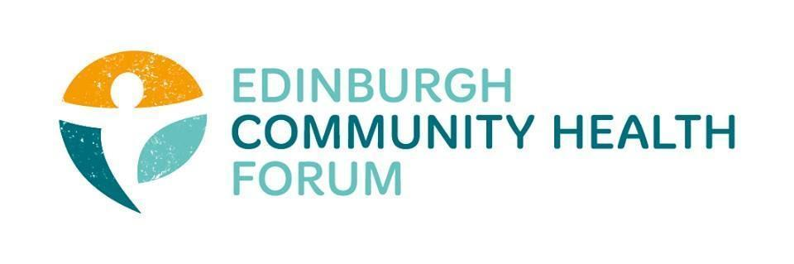Forum Meeting 05/05/2022

Attendees: Stephanie-Anne Harris (ECHF), Daniel Richards (ECHF), Charlie Cumming (ELGT), Isabell Coupland (MDP), Catriona Windle (HAR), Dawn Anderson (PCHP), Brenda Black (Edinburgh Community Food), Fiona Partington (THA), Helena Richards (CarrGomm), Marion Findlay (Volunteer Ed), Penny Richardson (ICJ), Susan Lancaster (LGBT H&W)
Apologies: Biddy Kelly (Fresh Start), John Halliday (Community Renewal trust), Anne Munro (PDP), Suzzanne Lowden ( H&SCP’ship), Brock Lueck (OPFS), Susan Paxton (SCDC), Ryan Lytwyn (PEP), Peter Scott (Murrayfield Club), Ruth MacLennan (Care4Carers), Magda Czarnecka (Feniks), Jen Richards (B Healthy Together)

- Welcome and Introductions:
Stephanie-Anne welcomed everyone and thanked them for coming
2. IJB
Stephanie-Anne gave everyone a small update on the progress of the IJB grant process:
Linda has approved a 2-year extension. There has been a recognition that this does lock people who don’t currently have funding out of the process.
Bit of a relief in the sector that we can get back to delivering services etc. instead of worrying about core funding.
However at some point over 23/24 we need to figure out what the new process will be

If they are trying to get a PSP going, over the next 12 months is there an expectation that as part of this process, new or existing organisations that don’t currently get money will be involved in that process but then have to wait 2 years to actually get a chance for funding?. Doesn’t make much sense.
Lots of questions still need to be asked. The exact amount of money, procurement process etc.
-If its not going to be grants then what is it going to be.

One member suggested that the funders (big funders) should be communicating with each other, there could be some effort made to make sure Edinburgh is covered- so if an organisation doesn’t get funding by IJB then the lottery could come in etc.
Something we could potentially get rolling as a Forum, invite heads from these funders to come along and discuss this kind of idea.

- Penny- Macmillan Transforming Cancer Care (TCC) Partnership’s Executive Group (EG)
Had a look through the cancer journey project- statistics for Edinburgh and collated some information for everyone- https://echf.org.uk/4308-2/
May be able to raise the profile of the project through the forum
Pre-habitation is a key aspect of the work that is being done, this involves doing the best you can to prepare for treatment. That might be improving diet, physical health etc. in order to maximise the likelihood of having successful treatment while also improving a persons mental capacity to cope.

The forum may be well placed to help support some of these things to improve the cancer journey.

Health inequalities are directly linked to late stage, much worse cancer being diagnosed- For example a lack of access to screening means cancer isn’t found until much later on.
- ECHF end of year review
If you would like to take part in our yearly review and contribute any thoughts and ideas for the future of the ECHF then please follow this link: https://www.supersurvey.com/QP2JRQO3W

- Minutes from meeting held on 05/04/2022
The minutes of the previous meeting were approved.

- Date of next meeting
June 7th, 2022. 11.30am- 1am on Zoom and in person at LifeCare

