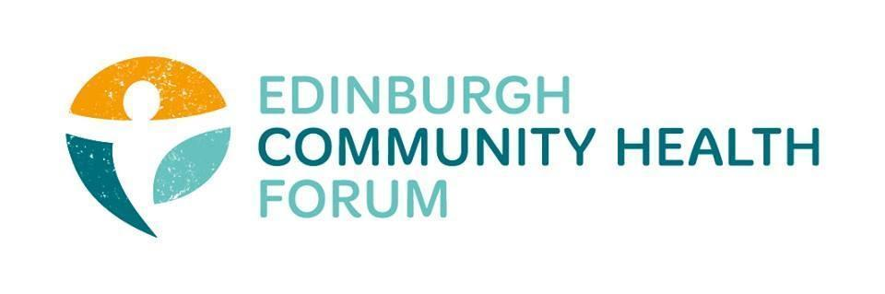
Forum Meeting Held at FourSquare offices and online via Zoom on 06/12/2022
Attendees in person: Daniel Richards (ECHF), Charlie Cumming (ELGT), Ryan Lytwyn (PEP), Magda Czarnecka (Feniks), Kerry Murray(NHS LPH), Brenda Black (ECF), Finn Claxon (spire), Helena Richards (Carrgomm)
Joined online: Stephanie-Anne Harris (ECHF), Margaret, Ruth MacLennan (Care4Carers), Dan Fuller (Libertus) Michelle Davit (LGBT health), Stephanie-Anne, Dawn Anderson (PCHP), Anne Munroe (PDP), Suzanne Lowden ( H&SCP’ship)
Apologies: Biddy Kelly (Fresh Start), John Halliday (community Renewal), Catriona Windle (Health all around), Brock Lueck (OPFS),
1. Welcome and Introduction- Charlie
Charlie welcomed everyone and thanked those who joined both in person and online
2. Update on the PACT- Linda Fitzpatrick- postponed until January
3. Marie Curie: lived Experience of caring for someone at home at end-of-life- Helen MacGregor
Marie Curie are currently in the process of gathering information on people with lived experience of giving end of care life.As an organisation they are currently reaching about 10% of those on end of life care in the UK.There are roughly 62k per year dying with palliative care each year. Marie Curie are looking at barriers and facilitators for end of care at home by engaging with those with lived experience
If anyone knows of groups or has access to people with live experience then please get in contact with Helen – Helen.MacGregor@mariecurie.org.uk
4. Update from Susan Paxton
Unfortunately Susan was not available ;however we will try and get her along to another meeting to give a national update/perspective.
5. Update on strategic Items- Stephanie Anne
Lottery Funding
Our application to the lottery funding was successful- this was done on behalf of 7 member organisations and will fund vital provisions for families including food vouchers, blankets and fuel vouchers over the winter.
Capacity to Collaborate Funding
Regarding the capacity to collaborate money we have almost committed the full 15k amount now. In addition , the Forum has been granted a further 2 years of this funding.
Helena-Carr gomm noted that she hasn’t heard back about reporting for the capacity to collaborate money- causing issues of uncertainty on what info to actually collect.
S-A- to follow up with Linda and update Helena.
Matter of Focus
The forum is working with a Matter of Focus, who are researching and then writing a report on the collective and added value of the Forum, its members , service delivery and impact as a follow up to this will follow on from the last report written after covid
6. Update from Forum members- Everyone
Brenda- ECF
Handing out close to a thousand themed boxes of food at Christmas.
Currently trying to focus on Ukrainian families and a demand for crisis food over the Christmas period as well as involved with food stalls set up inside hospitals. Noted that unions are also trying to setup foodbanks aimed at staff.
Charlie- ELGT
Making cost of living budget decisions early in order to help staff with the current cost of living crisis .
-Ties in with retention and hiring issues the sector is currently facing.
Helena- Carr gomm
Board just approved a mid year 1k bonus to everyone regardless of position or current salary.

7. Any other business- Everyone
There were no other matters to be discussed
8. DONM
The next meeting will be the 31st of Jan 2023, place currently tbd

