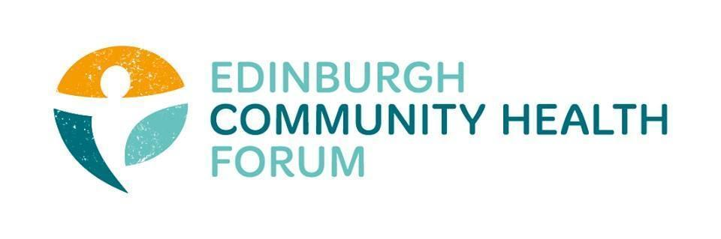
Forum Meeting Held at Carr Gomm offices and online via Zoom on 31/01/2023, at 10.00am
Attendees in person: Stephanie-Anne Harris (ECHF), Daniel Richards (ECHF), Charlie Cumming (ELGT), Brenda Black (ECF)chair, Helena Richards (Carr Gomm), Fin Clarkson (Space), Leah Black (EVOC), Claire Wheeler (Bridgend), Helen Tait (PEP), Beth ?? (PEP)
Joined online: Catriona Windle (Health All around), Michelle Davitt (LGBT Health), Ruth MacLennan (Care4Carers), Dan Fuller (Libertus), Danielle Campbell (DBFC), Kerry Murray(Health Scotland ?), Linda Fitzpatrick (PACT), Marion Findlay (Volunteer Ed), Suzanne Lowden ( H&SCP’ship), Ran Majumder (THA), Magda Czarnecka (Feniks),

Apologies: Dawn Anderson (PCHP), Anne Munro (PDP),

1. Welcome and introductions- Brenda
Brenda thanked everyone for coming and introduced the guest speakers, Leah Black and Linda Fitzpatrick.
2. Leah Black- EVOC
Leah is currently working with funders to create a entirely new fund for the city, if investors into the fund can bu sought. The idea of this is to have a carbon neutral- green funding pot which can be used for core funding, specific projects to stocking up unreserved funds.
Currently feedback is being collected and two working groups have been formed:one smaller closed group and a larger one to which anyone is welcome to join and offer their own ideas/feedback.
For an overview of the current draft plan for the fund go to: https://echf.org.uk/regenerative-futures-fund-updated-visual-plan-8-feb-2023/
If anyone wishes to be involved with giving feedback contact: leah.black@evoc.org.uk. Leah is happy to meet up with anyone who might want to be involved.
3. Update from Linda on the PACT
﻿The next Edinburgh Wellbeing Pact Stakeholder event will be at Norton Park on Thursday 30th March 9.30am – 12.30pm
The next Edinburgh Health and Social Care Strategic Plan – Consultation/Engagement Event will be on the 8th March at Norton Park.
The second round of the he Scottish Government’s mental health & wellbeing fund, is being distributed through EVOC; there is no new money available through this source and so Linda and EVOC colleagues are instead looking to redesign the decision making process on how this funding is allocated. It was noted that the report on the evaluation on the processes used in Round 1 of this funding is still to be published.
A report on the current IJB grant funding is being presented to the IJB’s performance committee and once approved can be shared with the Forum and its members.
4. The Big Hoose- Lochgelly
The Big Hoose is currently a project set up in Fife which distributes returned Amazon items(such as bedding, kitchen items, towels, toilet roll, nappies, rugs and other household furnishings and goods) to people in need.
The Big Hoose is keen to expand the distribution of the items to Edinburgh .Discussions are ongoing on the model of delivery that could be used : perhaps a hub in which larger amounts of items could be transported from Fife (say 2 deliveries per week) which could then be distributed amongst partner organisations.
If anyone would like to get involved with this project please get in contact with stephanie-anne@echf.org.uk
5. Update from Susan Paxton
Unfortunately Susan was not available; however, we will try and get her along to another meeting to give a national update/perspective.
6. Out Nav
ECHF is currently reviewing whether to continue funding OutNav for member organisations as it is currently a large percentage of our overall spending. We would like to collect everyone’s views on this matter and will send out a survey shortly.
Survey link: https://q6tdwz3qn.supersurvey.com

7. Update on strategic Items- Stephanie-Anne
Would recommend everyone read the “Leave no one behind” report as it focuses on important aspects of how health inequalities in Scotland has declined over the last 20 years.
Link: https://www.health.org.uk/publications/leave-no-one-behind
The work of Michael Marmot should also be on everyone’s radar. He is currently setting up a new network
A new UK wide network, backed by Sir Michael Marmot was launched on 24th January, it’s called the Health Equity Network (HEN) and hopes to concentrate efforts across the UK on narrowing health inequalities and decreasing life expectancy.
Link for more info: https://www.ucl.ac.uk/news/2023/jan/ucls-professor-sir-michael-marmot-launches-uks-first-health-equity-network
8. Update from Forum members- Everyone
Care for Carers- would like to offer an Invitation for Carers to consult on Edinburgh Health and Social Care Partnership Short Break Policy on Friday 24th February 9.30am – 1pm
(Refreshments and light lunch will be provided)
email: enquiries@care4carers.org.uk to register your interest.
9. Training opportunities
We currently have several training opportunities coming up.
20th Feb-3rd March- Building Diversity into Volunteering- If you are looking to increase the diversity of your volunteer pool and make your opportunities more accessible and welcoming this is the course for you.
April 18th-19th - Mental Health First Aid Training. -First aid approach focusing on a suicide led intervention which allows the candidates to understand the following mental health conditions; Anxiety, Depression, Suicide, Self-harm, Alcohol & Drugs, Psychosis, and Recovery, this also includes our Attitudes towards Mental Health and Listening Skills.

10. Any other business- Everyone
There was no other matters to be discussed.
11. DONM
The next meeting will be the 28th of Feb 2023, at 10.00am at FourSquare and via Zoom.

