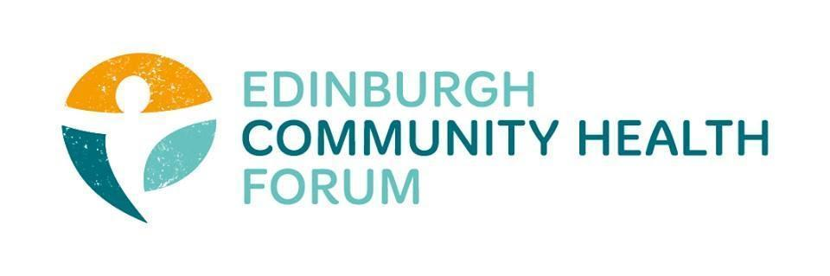
Forum Meeting Held at FourSquare offices and online via Zoom on 06/06/2023, at 10.00am
Attendees in person: Stephanie-Anne Harris (ECHF), Daniel Richards (ECHF), Catriona Windle (HAR)- Chair, Marion Findlay (Volunteer Ed) Helena Richards (Carr Gomm), Michelle Davitt (LGBT health)
Joined online: Magda Czarnecka (Feniks), Ruth MacLennan (C4C), Kerry Murray(NHS PH&HP), Nazia Majid (NKS), Ran Majumder (THA), Christopher Ward (Waverly Care), Claire Wheeler (Bridgend), Brenda Black (ECF), John Haliday (Community Renewal),

1. Welcome and introductions- Cat
Cat thanked everyone for coming and joining both in person and online

2. Update on the PACT- Linda

Unfortunately Linda could not make the Forum meeting as she was called for an mandatory meeting.
Instead S-A filled in the forum on any IJB updates
-Cat and S-A have been invited to a Symposium on solutions for the IJB and Pact to address the cost of living crisis- they will update at a further date

-There is a Pact meeting on Friday 23rd June coming up
-The IJB budget should be decided very soon, They have been asked to find 44 million in savings however so far only around 11 million have been found. Currently looking for other funding to help cover this shortfall.

3. Update on Outnav
We have decided to stop paying for OutNav for the forum as a whole.
If individual members wish to continue using the service they should contact us and we are happy to arrange covering part of the their subscription costs going forward.
Outnav isn’t currently used for other IJB stuff and so embedding it into contracts would help get more use from it, however until something like this happens its hard to justify for the average organisation to use it full time.

4. Update on AGM
Our next AGM will be on the 5th of September
We will try and get Sir Michael Marmot to come and speak, failing that we will look into other speakers who we think could help speak about health inequalities and really get some attention.
More details will be released at a later date.

5. AOCB

There was no other business to be attended to
6. Minutes and DONM
The minutes for the last meeting were approved.
The date of the next meeting will be on 5th Sep 2023 which will be our AGM
This will be held at Norton Park (not online) from 10am-11.30

