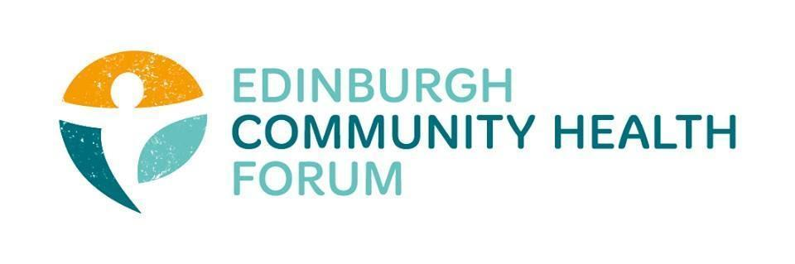
Annual General Meeting 05/09/2023
Held at Norton Park

Attendees: Stephanie-Anne Harris (ECHF), Daniel Richards (ECHF), Charlie Cumming (ELGT), Catriona Windle (HAR), Brenda Black (Edinburgh Community Food), Marion Findlay (Volunteer Ed.) Ryan Lytwyn (PEP), John Halliday (CRT), Alistair Mcintyre (Libertus), Chik Collins (GCPH), Kerry Murray (NHS Lothian), Dawn Anderson (PCHP), Tristan Green (The Ripple Project), Helena Richards (Carrgomm), Magda Czarnecka (Feniks)
Apologies: Ruth MacLennan (Care4Carers), Susan Paxton (SCDC), Ran Majumder (THA)

- Welcome and Introductions:
Cat welcomed everyone, thanked them for coming and introduced our guest speaker Chik Collins.
- Keynote Speaker- Chik Collins
Chik started his speech by posing some questions about ECHF’s values around communities being the best placed to improve their own health and asked us to think about how this might be shifting the responsibility for persistent health inequalities.

- He then gave a brief history of health inequalities and how they have been tracked, described and politicised over the last 25 years. Including some of the events with the largest impact such as:
- The ‘credit crunch’, the banking crisis, the great recession, Brexit
- Extreme government austerity (The Con-Dem Coalition)
- “Welfare reform” under Iain Duncan Smith – including brutal impacts on the long-term sick and disabled, and extreme sanctions (enforcing destitution).
Chik then goes on to talk about who has been the most affected-
Low- income households (<£20k)
Renters
Lone parents and single working age adults
Unemployed
People living in a household with a disability
BME households
Chik then goes on to show a series of graphs showing the stark increases in mortality rates for various groups. The graphs will be available to view on our website within Chik’s PowerPoint presentation.

To continue one of his first points there has been a trend towards pushing responsibility onto individuals and communities to tackle these issues. When at the root they are driven by policy decisions.
Discussion and questions for Chik were had for another 20 minutes and members discussed the causes and possible solutions as well as ECHF’s role going forward.

- Chairs Report
All board members were happy with the work of the forum in the previous year and all wished to continue their positions: Catriona Windle (Chair), Charlie Cumming (Treasurer), Maruska Greenwood (Trustee), Marion Findlay (Trustee), Brenda Black (Trustee) and John Haliday (Trustee). They were all re-elected successfully.

- Finance- Accounts 21/22
Published Accounts: https://echf.org.uk/echf-2021-22-accounts/
S-A went over the reserves, income and expenditure and where ECHF grants came from, which is also shown in the above report. The accounts were then approved for the year.
David Nicolls was the appointed independent examiner for the financial year and we would like to thank him and everyone else at Brett Nicholls Associates for their help.
David Nicolls was approved to be the independent financial examiner for the coming year.

- The year ahead
Important things to come include focusing on the IJB funding cycle which will come to a close in 2025.
-Before then there needs to be a solid new commissioning process in place
-something that would really need to be finished by the summer of 24 in order for people to start applying

We also still have funding for capacity to collaborate- both money left over from last year and another £15k for this year and a further £15k next April. Please get in contact if you wish to discuss a project with us.
Linda Irvine Fitzpatrick will be coming to the next forum meeting on the 3rd of October.
We will continue with training opportunities
-First aid training coming up soon
-GDPR training will also be coming up

- Minutes from the Previous AGM held on 11/10/22
The minutes of the previous AGM meeting were approved.

- Date of next meeting
The next meeting will be on 03/10/2023 at Volunteer Edinburgh from 10-11.30am, 222 Leith Walk, Edinburgh EH6 5EQ, UK. In person only.

