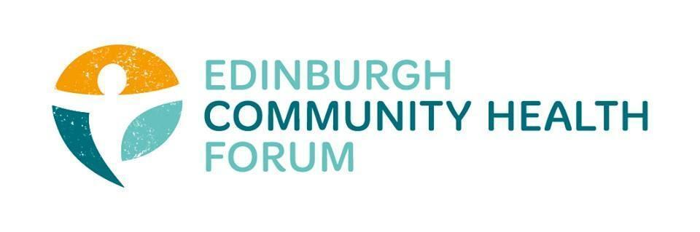

Forum Meeting Held at The Melting Pot on 09/11/2023, at 10.00am
Attendees in person: Stephanie-Anne Harris (ECHF), Daniel Richards (ECHF), Catriona Windle (HAR)- Chair

Welcome
- Welcome and introductions- Cat
Cat welcomed everyone and thanked them for joining

- Susan and Sarah- Update on SCDC
Susan updated the forum on her work at SCDC and brought up conversation regarding many of the issues currently facing the sector, some of which is captured below.
If CHEX can assist with the upcoming round of funding and best practice etc. then they would be happy to get involved
-Place and wellbeing plan
several strands of work one being
-community strand- enhance the capacity of community and third sector and increase wellbeing

TSI’s are the go to from Scottish government for funding 3rd sector

What does government need to do to build capacity for community led health organisations?
-Its not just about level of funding for orgs, but also about consistency of funding and longer term for stability for staff etc.
-Imbalance of power in partnership working between the sector commissioning the money
3rd sector delivers services fast- money is transparent and can move quickly however the current fundings cycles lead to instability and hurts long term planning

-Democracy matters- local governance bill to give more powers to communities- what would that look like?
What would additional powers look like for local organisations and communities

-Health and social care partnership not in a good state- several high up resignations, current yearly budget still not finalised, large budget deficit, awards still not given out for this financial year

Starting to coproduce new grants application and distribution process starting to fall behind timescale

Linda and the pact is focusing on early intervention and prevention strategy.
We want to try and put some evidence in front of the PACT showing the impact of the third sector

- ECHF update- S-A
The forum is still interested in creating an event (possibly with John Haliday) with someone like Michael marmot as a keynote speaker to raise the profile of health inequalities. One potential use of the money from Outnav that we now have free.
- Members updates- Everyone

- Any other business
MH fund- put onto agenda for next month
Fund is the same pot of money but they must fund new orgs in year 3

- Minutes and DONM
The minutes from the last meeting were approved.
Date of next meeting:
The next meeting will be on the 05/12/23 from 10am-11.30 held in person at Pilton Community Health Project, 73 Boswall Pkwy, Edinburgh EH5 2PW, UK

