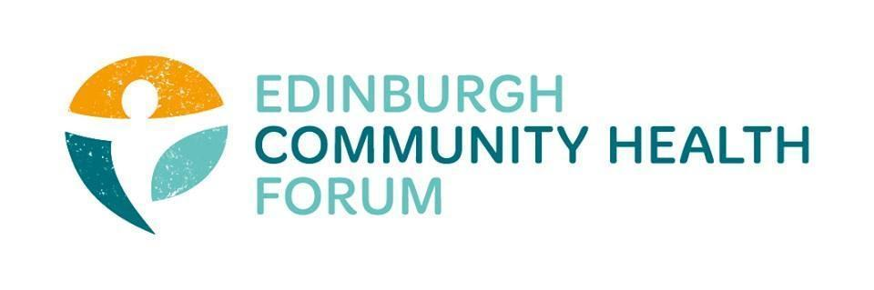
Forum Meeting Held at Volunteer Edinburgh offices on 03/10/2023, at 10.00am
Attendees in person: Daniel Richards (ECHF), Catriona Windle (HAR)- Chair, Marion Findlay (Volunteer Ed), Christopher Mantle (ECF), Linda Irvine-Fitzpatrick (), Suzanne Lowden (CEC), Fanette Gernaice (Fresh Start), Helen Tait (PEP), Diane Lee (LGBT Health), Danni Szerszynska (The junction), Charlie Cumming (ELGT)

Apologies: Helena Richards (Carrgomm), Michelle Davitt (LGBT Health), Ryan Lytwyn (PEP), Brenda Black (ECF), Ran Majumder (THA), Mitra Rostami (ELREC)

- Welcome and Introductions- Cat
Cat introduced everyone and thanked everyone for joining
- Update on the Pact- Linda
Linda updated the forum on the work she has been doing recently regarding the Prevention and early intervention strategy in Edinburgh
This included both strategy items, future goals for the project as well as sharing statistics and data from her research.
The full slides and information can be found on our website at: https://echf.org.uk/prevention-and-early-intervention-for-edinburgh/
Linda asked for anyone with helpful ideas on the prevention strategy to email her and let her know- Linda.IrvineFitzpatrick@nhslothian.scot.nhs.uk
Regarding the IJB budget, Linda said they were hopeful they would have more information in early-mid November but that as of now they couldn’t commit to giving any information on what will happen with it.

- Update on ECHF training- Daniel
We have just completed our First Aid training which was very successful and had a full house of 22 people complete and get their certificates for First Aid training in the workplace.
We still have some GDPR and data handling training coming up on the 8th of November. Full info can be found: https://www.eventbrite.co.uk/e/gdpr-training-tickets-721303898377?aff=oddtdtcreator
Please email daniel@echf.org.uk for a place as we do still have spaces available.

- Member updates

-The junction has their Counselling services back up and running now and have free spaces as they have some new Volunteer Counsellors, please email danni@the-junction.org for more information.
-Edinburgh Community Food have their Menu for All launch event on Friday the 6th which everyone is invited to join
They also have their AGM on the 10th

- Any other business
There was no other business to attend to

- Minutes and DONM
The minutes from the last meeting were approved
The next Forum Meeting will be held on 9th of November at 10am, place tbd

