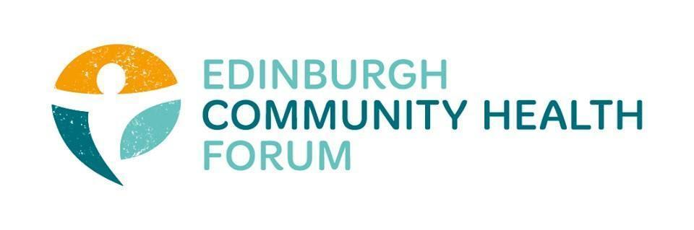

Forum Meeting held at Pilton Community Health Project on 5/12/23 at 10.00am

Agenda:
1. Welcome and introductions- Brenda
Brenda introduced everyone and thanked everyone for joining
2. Update on Menu for all- Brenda

Menu for all is a new network for food distribution and access support- which came about as a continuation from the collaboration and work between different orgs over covid

Scottish government is currently pushing a cash first approach which is something Menu for all is looking to help implement.

Menu for all has put in funding application and successful got 200k for Edinburgh to help facilitate a cash first approach
- Unfortunately this funding will be retrospective which is very exclusive for 3rd sector orgs involved. Cash flow issue for orgs, loss of interest payments on money etc. This is something Brenda will be pushing back against
There will also be a mapping exercise to map food distribution across the city.

3. Supervision / reflective practice - Charlie/Cat

Charlie will be having 1 on 1 chats with all members of staff- some are identifying that they need support dealing with mental health and complex mental health needs of service users at events
The complexity of the issues that people are turning up with is increasing

CLWs are getting support to deal with these issues – can talk once a month to a psychologist- replicable approach for orgs?

-So its about making sure staff have training for supporting people- however its also about where it’s appropriate to end that support - if a staff member is employed for a certain job should it be their job to be a mental health expert as well?

Can be very challenging for staff especially for singular staff members who are running projects
-Safeguarding issues for individual staff
-however just giving staff training to deal with these issues is just a band aid solution for the root problem

-Identifying which activities are suitable for those with complex needs- setting strong boundaries for what services you can provide and not provide

Forum has some capacity to collaborate money- could we fund a small group from a few orgs to come together and figure out what support the staff might want

4. Updates : 3 year strategy for the Forum; Early Intervention and Prevention Strategy; evaluation

Thrive has launched a new podcast series- https://keeping-edinburgh.captivate.fm/

Small grants fund up to £500 ends 8th of December

Draft strategy out sometime next year

Strategy- we will be formalising ECHF’s strategy
Pat tucker- new chief officer did presentation on IJB strategy plan
Talked about difficult for funding arrangements for 3rd sector- no solutions but at least its on his agenda

S-A- talked to Chik and Jen at Glasgow centre population for health- Focus on Harm reduction and Mitigation, minimising suffering
5. Members updates- Everyone

Feniks- Launched carers report showing barriers that polish carers experience living in Scotland, Language barriers as well as cultural barriers regarding what expectations of care are

6. Any other business

There was no other business to attend to

8. Minutes and DONM
The previous meetings minutes were approved
The January meeting taking place on 09.01.24 will be an informal coffee catchup session held at The Undercroft Café 10.30-11am

