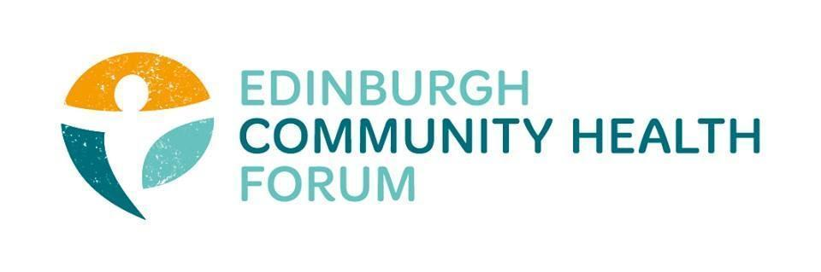
Forum Meeting 11/02/2025, Four Square and online

Attended in person: Stephanie-Anne Harris (ECHF), Daniel Richards (ECHF), Brenda Black (ECF), Catriona Windle (HAR), Zoe Mobey (THA), John Haliday (CRT), Mark (Citizens Advice), Marion Findlay ( VE), Dawn Anderson ( PCPH)
Joined online: Suzanne Lowden (H&SCP’ship), Dan Fuller (Libertus), Caroline McKinna (Dove Centre), Patricia Scotland (POPP), Michelle Davvit (LGBT Health), Christopher Ward (Waverly Care), Biddy Kelly (Fresh Start), Gillian Smith (QC), Ruth MacLennan (C4C), Anne Munro (PDP) Iona McCann (Art in Healthcare), Teresa Sutherland (CHAI), Jennifer Fairgrieve (Libertus), Maggie Chiwanza , Philem Headway, Helena Richards (Carr Gomm)
In attendance : Andy Hall, Service Director Strategic Planning, EIJB

Apologies: Sarah Boath (SCDC), Georgia Artus (Vintage Vibes),

- Welcome and Introductions
Cat welcomed everyone to the meeting and introduced Andy Hall, thanking him for attending in person

- The EIJB draft Strategic Plan
Andy Hall gave an overview : Current strategic plan out of date, it was 2019-2022, and is now 3 years overdue. The new draft been in process for a number of years and went out for consultation last June. Whilst some positive feedback was received , there was
negative feedback on the plan being vague, overly optimistic in the current financial climate , lacking concrete actions, being too academic etc. The new draft builds on the previous one but has been significantly revised. Andy noted that the original consultation from last June has been reopened on the Council’s consultation website and encouraged everyone to complete the questions/prompts by the current deadline of 23/2. It is hoped that an easy read version of the plan will be available shortly. Andy asked members of the Forum fo their views/feedback :
Are the priorities the right ones ? Are the population groups correct ? Are the measures and deliverables what you would expect ?
A general discussion followed :
John Halliday : Community health organisations are not mentioned in the plan but we should be recognising that there is a need to build on the strengths of community health and that the 3rd sector is crucial to delivering health in the city. John argued that the 3rd sector needs to be acknowledged as being part of the system and adding value to preventative work.
Andy responded by saying that he didn’t want to seem like the 3rd is sector is being taken for granted . The 3rd sector is not mentioned to keep it really open as the delivery priorities will be identified in the implementation plan which will follow once the Strategy is approved

Patricia argued that the plan has taken a very narrow view of early intervention and prevention, with Andy responding that his definition was broad and the examples given were strong and evidence based, in terms of return on investment
Andy described the 10 population groups covered by the plan and that the interventions described in the plan will have a shorter timeline for impact and ROI than intervention programmes that were being delivered through the grants programme .
.

Brenda- 3rd sector organisations are being taken off the table by not being mentioned by the strategic plan . 11% of the population is food insecure. Need to make sure that food help is integrated into support being offered .

Andy replied that he has no argument in principle but where would Brenda want to see food included, perhaps under frailty ? Brenda wanted to see a more broad base response and would be working up specific feedback on ‘food’ .
Ruth, representing Carers expressed her view to return to the wording and ambition of the previous draft strategy , including the vision of “More good days” .Ruth argued for :
wellbeing; resilient communities and Valued and healthy workforce to be prioritised again in this strategy
Some general comments were expressed that the Outcome measures were too quantitative and clinically focused and thee were insufficient qualitative measures and outcomes
Andy noted that the Prevention of Carer breakdown, and unpaid carers , in relation to the Carers Act Duty will be added into the revised plan.

Brenda suggested there needed to be more of a focus on Quality of life in the Plan rather than critical care and have ambition to supporting people to live healthier lives .

Members really felt the word ‘well being’ should
be included in the plan but this was resisted by Andy . Andy happy to look at revisions but there needs to be robust measurements and evidence

Marion focused on Volunteering and Loss of services and the impact on people who volunteer- not part of the conventional workforce but still provide immense value. These opportunities will be lost as 3rd sector loses orgs and capacity. Also no mention of isolation anywhere in the plan and its impact on health.

All members : We need to respond to the consultation but also include joined up key points to make sure our messaging is consistent. List of key messages will be drawn up and circulated for use.

- S-A update
TSI Reference group- written to all 5 political groups of the Council to request c £2m for funding the sector in the Council’s budget setting for 25/26
TSI Reference group preparing slides on the Plan for sector’s own consultation .
ECHF currently has another press release going out later this week- importance of funding for community health organisations.
Important to continue to influence local councillors between now and next Thursday (budget meeting)

- Training
If anyone has any training or support needs from the forum please let us know.

- AOCB- There was no other business to attend to

- Date of next meeting
The next meeting will take place 04.03.2025 at Volunteer Edinburgh and online via zoom. 10am-11.30

