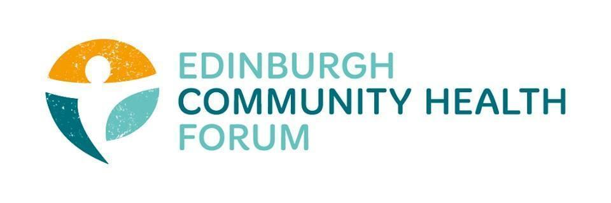
Forum Meeting 01/10/2024, Held at the Foursquare Offices and Online via Zoom, 10am-11.30am

Joined In person: Stephanie-Anne Harris (ECHF), Daniel Richards (ECHF), Brenda Black (ECF), Helena Richards (Carrgomm), Ryan Lytwyn (PEP), Catriona Windle (HAR), Patricia Scotland (POPP), Rose White (POPP), Dawn Anderson (PCHP), John Haliday (Community Renewal), Magda Czarnecka (Feniks)
Joined Online: Carolina Mckinna (The Dove Centre), Dan Fuller (Libertus), Suzanne Lowden (H&SCP’ship), Kellie mercer (CIC), Rossi Craig (THA)

Apologies: Sarah Boath (SCDC)

- Introductions- Catriona Windle
Cat welcomed everyone and thanked them all for joining both in person and online

- Feedback from meeting with SPG Councillors
-With Linda leaving and EVOC not being fully operational it has made communication harder with the EIJB, but Tim Pogson did agree to try and involve the 3rd sector more going forward and wants to see them consulted on decision making
-Potential for S-A to be involved in the budgetary meetings going forward
-Reality is that there is a huge deficit that needs to be covered and its only going to get worse in the coming years.
-Should the 3rd Sec be consulted on across the boar cuts vs targeted cuts
-We made the point that the timing of information is really important for the 3rd sector as we have redundancy notices etc. that orgs need to think about
-Its not acceptable to wait until the last moment to inform of us budget cuts etc.

-Tim Pogson didn’t know what an PSP was and said that it was not in conversations as board members of the IJB, so seems unlikely that a PSP is coming

- IJB update, including the strategic plan
Even though we don’t like the plan in its current form we want it to be stronger and don’t wont to weaken it.

A proforma has gone out, a scoring mechanism to judge all grant recipients
- Most orgs are scoring highly

Send a follow up email to Vickey/Alice to put forward motion for S-A to join next meeting.
Member question- Should we actually be pitching an increase so they compromise to a 0% cut rather than trying to argue on how much a potential cut would be

-Lots of IJB staff have left

- Meeting with Moira Pringle re grant extension for 25/26
S-A has a meeting with Moira, Andy, Pat to discuss a possible extension of the grants programme and also to get answers on things like a potential PSP

Suzanne- it is called the IJB grants programme and should we be labelling the grants as prevention spending
-this would position ECHF nicely

- media campaign
We should be using similar language when engaging in media

We will be starting a media campaign shortly and are looking at getting someone in to help with that

-potentially go to CHEX and Poverty Alliance as they have done some good work in the past with messaging etc.

S-A would also encourage everyone to contact councillors, MP’s etc. regularly

- members updates

Benda- Launching new Tuk Tuk education vehicle, which can be brought anywhere in the city
Get in touch with Brenda if anyone has an event that they would like to have it at

Rose- POPP have two lunch clubs aimed at reducing isolation

- Training
We have just run our ASSIST training and now don’t have anything planned so if anyone has any suggestions for things that would be helpful please contact Daniel

- Next meeting
Our next meeting will be on the 5th November 10am-11.30, place tbd

