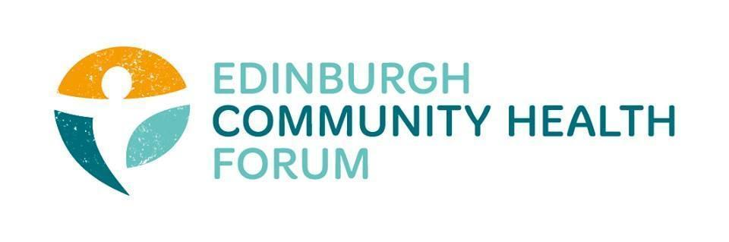
Forum Meeting held at Volunteer Edinburgh offices on 04/03/25 at 10am-11.30am

In person: Daniel Richards, John Haliday, Marion Findlay, Catriona Windle, Charlie Cummings, Helena Richards
Online: Alan Gray, Dawn Anderson, Anne Munroe, Patrica Scotland, Phelim O’toole, Dan Fuller, Benjamin Napier, Georgia Artus, Kellie Mercer, Magda Czarnecka, Iona McCan, Liz McIntosh, Ruth MacLennan, Brenda Black, Kim Anderson

Apologies: Rebecca Dickson (Bhealthy), Sarah Boath (CHEX), Cara Spence ( The Junction)

- What do our members like/dislike about the report ?
-Positive is that it is a substantial pot of funding and considering the position the sector was in at the end of last year it is a big improvement

-The two stage system doesn’t seem like the best way to do it.
It should just be a single application for core funding
Also should be clear before the end of April otherwise organisations are being put in the same position of risking redundancies just from the uncertainty of keeping future funding

-Issue of the terminology of “core funding”
-Many of the orgs rely on a single core funder and are funded mainly for services not rent etc.
-Although there are currently orgs that will definitely close with the current proposal many of these will lose core services and staff and then be forced to close in a years time anyway
- There isn’t much point only having core managers and no staff or service provision

-The language around “funded by the council” should be changed to “provide vital services for the council”
-Lots of orgs don’t receive council funding so it seems like it currently excludes a lot of the 64 orgs

-John suggested that there could be an exception for existing orgs to receive smaller amounts to allow them to survive in the short term
-light touch but small amounts of 10-15k for core costs
2. What do they think about the timeline , process, panel, criteria of resilience fund ?
Decision needs to be made before April as funding currently runs out at the end of June as orgs risk redundancies anyway otherwise

-Question
-Will orgs be told if they are eligible by the council? As this would save time and effort
-Suzanne doesn’t know as they don’t have access the necessary information that would determine if an org does fall under the guidelines set out
-also said she had been asked for the distribution list and so orgs will likely receive some kind of communication in the next day or so.
This is potentially a copy of the report but is unsure what it will contain or if any additional information will be provided

-Clarification is needed on whether CLW funding would count towards “receiving funding from the council”

- what do members think of the detail around the income max section and the lack of detail on all of our grants ?
-We should focus messaging on the language of “lifting people out of poverty” to run alongside the income max stream
-The criteria for our grant section seem to have been written before the budget was set and based on a much smaller amount of money

- Deputations-
No one present is currently planning on doing one
Benjamin is undecided
Anne Munroe is also undecided and wants to see how the next few days go

- Strategic plan feedback
-never ended up being an easy ready version
-Lots of basic things missed out such as Violence against women, social determinants of Health and refugee/migrant health
-Social model of health removed from the conversation
-Carer part that Andy said he was going to add in hasn’t been seen either

- AOCB
There was no other business to attend to

- DONM
The next meeting will be held on 1st April 10am-11.30 at the Foursquare Offices and via Zoom

