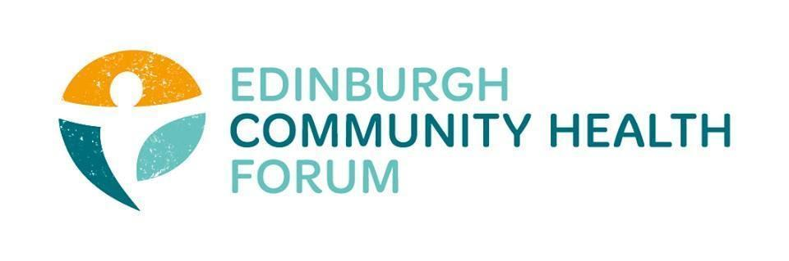
Forum Meeting held at Volunteer Edinburgh offices on 01/04/25 at 10am-11.30am

Attended In Person: Stephanie-Anne Harris (ECHF), Daniel Richards (ECHF), Catriona Windle (HAR), Charlie Cumming (ELGT), Michelle Davit (LGBTHealth), Helena Richards (Carrgomm)
Joined Online: Benjamin Napier (), Georgia Artus (Vintage Vibes), Christopher Ward (Waverly Care), Kellie Mercer (CIC), Phelim O’Toole (EHG), Patricia Scotland (POPP), Alan Gray (HAR), Isabell Coupland (MDP)

- Third Sector Resilience Fund and wider review of the 3rd Sector
Last Friday at 10oclock received email with copy of form and specification
-If you are struggling with the 11th April deadline, call Eleanor and ask for an extension because you will get one
-don’t include to much financial information that isn’t known

-Many orgs are facing service closures and staff redundancies unless they manage to get the funding for core costs
-Most that are applying will still see services affected and have had to cut hours for staff etc.
-Many of these services are critical for the EIJB so conversations need to be had about who’s responsibility it is for these services.

-Several orgs have said they are struggling with the deadline, all have been urged to ask for extensions

-This is only a short term reprieve, unless future core funding is found a lot of orgs will be in the same position this time next year

Send an email out to everyone, has anyone had reductions to SLA’s ?

Volunteer management costs can be involved in the

- Update from Third Sector Reference Group meeting with Christine Lavery, the new CO of the H & S C P'Ship
Positive meeting
Said that she is new and there are things she wants to change but cant necessarily stop unfortunately
-A lot of talk about how orgs align with strategic plan
-Not sure why she cant pause the strategic plan, as it wont be released until the summer
-think about how we want to proceed to pressure her

- Strategic Plan
apparently there is an easy read version of the strategic plan and they have extended the consultation so we need to get involved with that and make sure that feedback is given.

- Social Media- use of twitter
We are currently reviewing our use of social media, specifically with Twitter. Overall we would like to move away from twitter and potentially move to Bluesky. If you have any feedback on this it would be useful to hear your own social media strategies regarding this going forward

- Training/development support
If there is any training for yourselves or staff that would be useful please get in touch with us.

- Date of next meeting(s)
The next forum meeting will be on the 29th April 10am-11.30 at the Foursquare offices and online via Zoom.

We will also hold and informal coffee catchup at the Undercroft café 10.30am -12pm on the 13th May.

