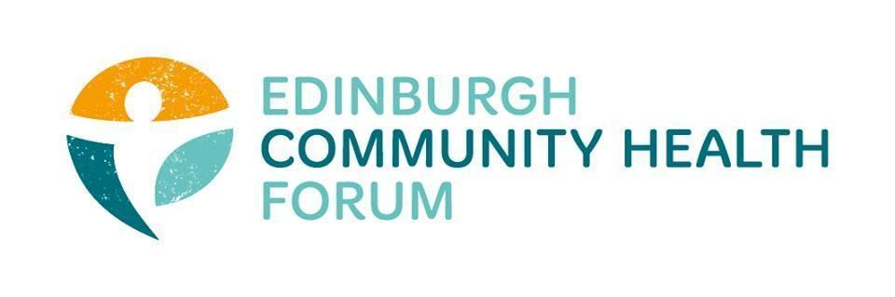
Forum Meeting 04/11/25 , held Online via Zoom, 2.00pm -3.30pm
Joined Online: Stephanie-Anne Harris (ECHF), Brenda Black (ECF and co-chair) , Helena Richards (Carr Gomm), Patricia Scotland (POPP), Magda Czarnecka (Feniks), Benjamin Napier (Citizens Advice ), Charlie Cumming (ELGT and co-chair), Dawn Anderson (PCHP), Archie Campbell (We are Compass), Alan Grey ( HAR),Vanessa Paynton (Art in Healthcare), Kellie mercer (CIC), Andrew Ainsworth(Vintage Vibes), Zoe Mobey (THA), Ruth Maclennan (C4C), Rebecca Dickson (BHealthy2Gether ), Liz Macintosh(QCCC)), Anne Munro ( Pilmeny), John Webster ( MPP), Marion Findlay ( VE)
Apologies: Sarah Boath (SCDC) , Daniel Richards (ECHF), John Halliday (Community Renewal),

- Introductions- Brenda Black
Brenda welcomed everyone and thanked them all for joining online
- Guest Speaker: Cecille Dambo, Quit Your Way NHS Stop Smoking Service
Cecille gave an interesting and thought provoking presentation with the most recent statistics. (presentation slides to be shared and put on our website).Stats still very concerning for those from the most deprived areas of Edinburgh . Members felt that more could be done through working with organisations directly in communities. Encouraged members to make referrals using the following email address: loth.smokefreeedinburgh@nhs.scot, self-referral phoneline : 0131 2865113

- Funding Update
Still awaiting an update from Gillie Severin to discuss the next steps of the Third Sector Review and the likelihood of funding for 26/27 and beyond. Also, meetings to be arranged with the political groups to influence the Council budget setting for next year. Discussed the focus of any funding prioritising addressing poverty, and the 5 neighbourhood prevention partnerships.
Participatory Budgeting: there will be new monies coming onstream through the Visitors Levy. Important to continue to make the case to Councillors for monies to be allocated for core funding and not only project funding.
Regenerative Futures Trust: brief discussion on the progress being made, although noted that of the 34 chosen for the cohort, there were few ( if any ) who were members of the Forum . The Trust’s website (https://regenerativefuturesfund.org.uk/) has the up to date information.

- Third Sector Reference Group(TSFG)
Meetings are now being held monthly, and the original TOR are now being rewritten to reflect the current position. Highly likely that the numbers on the TSFG will be reduced, but there will be more focused working groups to drive forward the key issues for the sector. Some suggested topics for working groups include Evaluation and Adult protection. Also, work will commence shortly on a web page for the Group for minutes, actions etc that will be accessible to all.

- Training and Mentoring Opportunities
Support and mentoring is available to members from a trusted and very committed volunteer. Please get in touch with Marion if this is of interest and she can put you in contact.

- Members Updates
Archie from Compass invited everyone to their Open Day on 20/11 from 2.00pm- 4.00pm. Please email Archie if you intend to go.
Helena highlighted the information being promoted by the CLWS network which demonstrates the strong connections to many 3rd sector organisations.

- AOCB
Noted that the recent Poverty Commission event was well attended and there is another call for action. You can read the report here : https://edinburghpovertycommission.org.uk/wp-content/uploads/2025/10/Edinburgh-Poverty-Commission-2025-Calls-to-Action.pdf

- Date of next meetings:
There will be an in person coffee and cake catch up session on Tuesday 13th January at 10.30 in the Undercroft Café, George Street.
The next forum meeting will be on the 3rd of February 10-11.30am in person and on Zoom.

