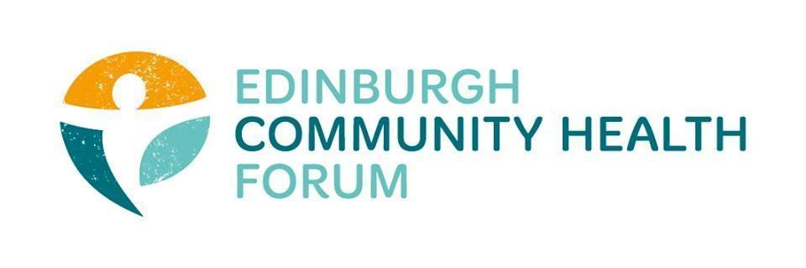
Forum Meeting held at Four Square offices on 02/12/25 at 10am-11.30am

In person: Stephanie-Anne Harris (ECHF), Daniel Richards (ECHF), Brenda Black (ECF), Charlie Cumming (ELGT), Helena Richards (Carr Gomm), Kim Buckley (THA), Benjamin Napier (CAE), Alan Gray (HAR), Magda Czarnecka (Fenicks), Marion Findlay (VE)

Online :Anne Munroe (PDP), Andrew (Vintage Vibes), Gillian Smith (QCCC), John Haliday (CRT)
Apologies : Patricia Scotland (POPP), Suzanne Lowden (H&SCP), Anne Munroe (PDP), Biddy Kelly (Fresh Start), Sarah Boath (CHEX)
Guest Speaker: Roddy Ferguson (St Columba’s Hospice)

- Welcome and introductions (Brenda)
Brenda welcomed everyone and thanked them for joining online and in person

- Guest speaker: Roddy Ferguson- St Columba's Hospice
St Columba’s Hospice deals with palliative care, with the view that death is inevitable and reducing suffering, increasing comfort (both mental and physical) is important for those facing end of life circumstances
They already have several groups at the hospice including Art Therapy, Music Therapy and Walking groups.
-The Hospice wants to connect with orgs to see what services are already out there as well as to share resources if possible.
-Hospice has training events for helping people to talk about death, if anyone ever has anyone that this might be relevant for, they can always refer them to the hospice.
If anyone would like to discuss more with Roddy you can get in touch with him via: RFerguson@stcolumbashospice.org.uk
- Prevention, Early Intervention and Mitigation Paper – discussion
A discussion around the paper was had, some highlights are captured below:
-On page 1 of the paper regarding things they should do- should mention communities
-how are they going to support 3rd sector- great that they mention the 3rd sector but specific details are needed.
-with regards to the prevention board- who and how are the people selected ?
-What is the proposed budget?
-What do they intend to do, so far lots of vague statements but nothing clear or specific
So far it feels like a continuation of the resilience fund
-Unsure if the pot will fund projects that are currently running
-We are likely to see something more concrete out of the meeting on the 10th
-They need to be clearer on who they want to fund and what info they will want for both evaluation and for applying for the fund.
Any other comments on the paper, send them on to S-A
- Funding
-Deputations went well
-Paper going through about extending funding
-£4.6m in funding from April is reoccurring
-Continuation of the resilience fund
And then at some point discussions around the recommissioning process will have to start
Currently have meetings with the Libdem, SNP and Labour Groups we are still waiting to hear back from the Conservatives and Greens.
But overall, these talks have been going well and everyone seems to be on the same page so far.
- Training/Coaching
We will try and get either some ASIST training or First aid (Basic) training in place over the coming months.

- Evaluation and a Matter of Focus
Matter of Focus has now wound up and as a result “Plinth” has taken over the service of Outnav.
Worth keeping an eye on if this is worth engaging with over the coming years.
May also reach out to the people who ran Outnav to look at getting some evaluation pieces done for the Forum

- 30th birthday celebrations

Anyone who has ideas or would like to help with preparations for the Forums 30th anniversary should contact Daniel or S-A.

- Members updates

-Immigration changes highlighted
-Get points from volunteering, this Is going to put a huge amount of pressure on the 3rd sec and flood it with people who don’t really want to volunteer but are essentially being forced to for immigration purposes.
-Bill out for consultation- will send round

- AOCB
There was no other business to attend to

- Date of next meetings
20th of Jan- Informal coffee catchup
3rd Feb- Next Forum Meeting

