Follow-up Joint Statement on Prevention
January 2026

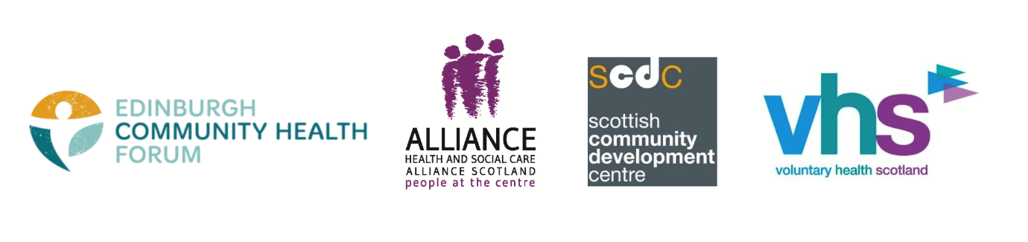

Putting the 'hard-to-do' parts of preventative policy into practice

In September 2025, our organisations came together to issue a joint statement on the role prevention plays in tackling Scotland’s growing health inequalities crisis.

These preventative approaches mean identifying and tackling root causes before negative outcomes occur. They focus on addressing the underlying causes of the unfair and avoidable differences in how long people live, and live in good health.

In our statement, we called for a clear definition and understanding of what prevention means, a properly resourced third sector that’s part of a whole systems approach, and an urgency in how we tackle the ‘hard-to-do’ parts of policy implementation.

Ahead of the 2026-27 Scottish Budget, we want to restate the necessary steps required to tackle the ‘hard-to-do’ policy ambitions related to prevention. Finding sustainable solutions to the ‘implementation gap’ is essential if we’re to translate policy into action that meaningfully improves people’s lives, and addresses the issues that they face every day.

There have been positive signs since we published our joint statement that the Scottish Government and other public sector partners are serious about creating a prevention-centred system. We have all been at various meetings in recent months with partners exploring a range of solutions, including preventative budgeting and greater power-sharing with communities experiencing the impact of health inequalities and the third sector.

However, there is little doubt that the current fiscal environment puts cross-sector ambitions around prevention in and with communities at risk.

Systems change takes time; but this is something many of our collective members and stakeholders are running out of. Without immediate action to sustainably invest in preventative solutions, we risk losing many of the groups, organisations and practitioners skilled and experienced in long term, preventative work.

So, what needs to be done?

While none of these problems are easy, there are clear paths towards achieving this much needed change. In our joint statement, we set out some of these steps:

- Co-production and power-sharing with people, communities and the third sector;
- Long-term investment and work;
- Transparency and accountability;
- Courageous leadership;
- Evidence-gathering; and
- Working across siloes and sectors (including fiscal)

We therefore encourage the Scottish Government, and specifically the Cabinet Secretary for Finance and Local Government, to demonstrate courageous leadership in the Scottish Budget. Financial decision-making and reporting which prioritises and transparently allocates and tracks spend on prevention is vital. It is also crucial to ensure that financial decision-making power is meaningfully shared with community and third sector organisations as equal partners in the shift to prevention.

Through collaboration and with a shared vision, solving this implementation gap is possible.

However, the pace of the change required is also clear. The real-world impacts of Scotland’s health inequalities crisis are apparent across our communities.

To rise to this challenge, we need to move urgently and consistently - together - so that prevention becomes not just a policy ambition, but a policy success.

Follow-up joint statement by:

Edinburgh Community Health Forum
Health and Social Care Alliance Scotland (the ALLIANCE)
Scottish Community Development Centre: Community Health Exchange
Voluntary Health Scotland

End of document.

