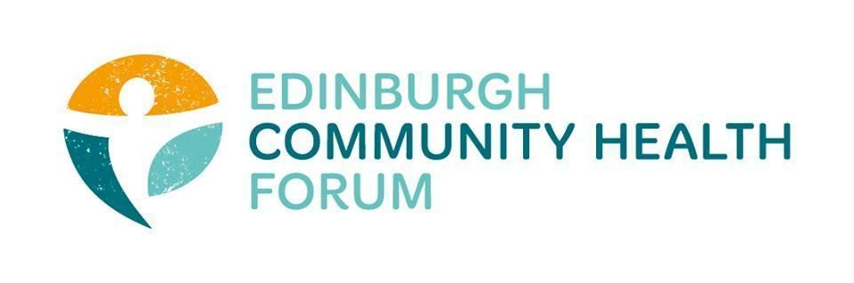
Forum Meeting held at Volunteer Edinburgh Offices and online via Zoom 03/02/2026

Attended in person: Daniel Richards (ECHF), Brenda Black (ECF), Helena Richards (Carr Gomm), Benjamin Napier (CAB), Marion Findlay (Volunteer Ed)
Attended online: Stephanie-Anne Harris (ECHF), John Webster (MDP), Kim Buckley (THS), Phelim O’Toole(Ed Headway), Dan Fuller (Libertus), Liz McIntosh (QCCC), Sarah Van Putten (LifeCare), Charlie Cumming (ELGT), Kellie Mercer (CIC), Magda Czarnecka (Feniks), John Haliday (CRT), Alan Gray (HAR)
Guest Speaker: Steve Lawrence (Social Enterprise Scotland)

- Welcome and Introductions
Brenda welcomed everyone and thanked them for joining both in person and online.

- Social Enterprise Scotland- Steve Lawrence

There is a social enterprise code in Scotland, this means we have a very strong sector. Especially in Edinburgh and Glasgow.
-It is part of the TSI
-Around 88% pay a real living wage
-SES can help prepare members to develop
-Help to signpost to relevant organizations that can give a good experience
-Commissions members to deliver training
-Help with marketing and videos

-even if you aren’t a SE, they are still keen to connect
-Consultancy side of things to talk through what orgs current ly have on offer

-6,103 social enterprises currently operating in Scotland (776 / 13% of the total in Edinburgh)
- 60% female leadership
- £5.2 billion total annual income
- £2.89 billion GVA
- 90,050 FTE jobs
- 88% pay the real living wage

- Budget proposal and report to P & S on 3rd sector funding
Paper will be going to committee next Tuesday
-report is as was expected
-Currently saying it all has to be done by November with coproduction by June
-This would mean applications would need to be in by August
-For those who have resilience funding if you are successful then the RF would stop and you would start getting the new funding
- However if you applied and did not get funding then your RF would just continue

-We don’t currently have an idea regarding eligibility
-Also a worry that if we lose the targeting funding streams and it is all coagulated, then you would lose some of the specific focus on those areas.

-Some orgs just don’t have the capacity for these timelines
-Is there going to be time to give proper feedback on the initial co-production?

- Training Update
We still have a few spaces left on the ASIST training so please get in touch with Daniel if you wish to take part.
We are also looking at running some Autism awareness in the workplace training later in the year.

5. Use of AI- Discussion
We are looking into resources that might helps orgs to use AI safely in their work. We are also open to any feedback about orgs current AI policies and implementations.

7. DONM
The next meeting will be the 15th of April, Online only via zoom, 10am-11.30

