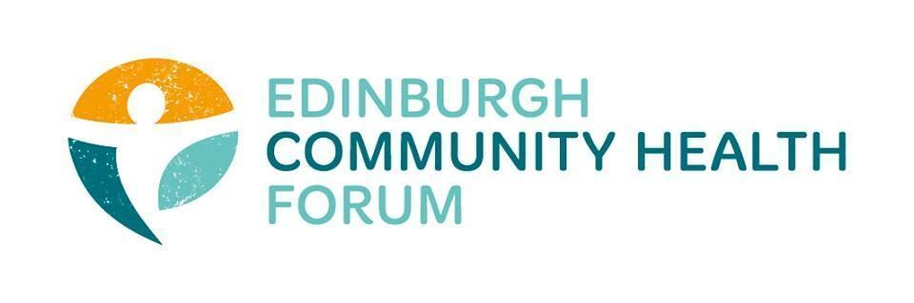
Forum Meeting held at Edinburgh Quaker House meeting space on 05/05/2026

Attended in person: Daniel Richards (ECHF), Stephanie Anne-Harris (ECHF) Brenda Black (ECF), Benjamin Napier (CAB), Marion Findlay (Volunteer Ed), Fanette Genais (Fresh Start), Patricia Scotland (POPP), Gillian Smith (QCCC), Liz McIntosh (QCCC), Magda Czarnecka (FENIKS), Charlie Cumming (ELGT), Darcey McCutchean (Dr Bells), Zoe Mobey (THA), Vanessa Payton (AIH), Helena Richards (Carr Gomm), Dan Fuller (Libertus), John Haliday (CRT), John Webster (MDP), Emma Galloway (ERCC), Alan Gray (HAR)

Guest Speaker: Chris Adams (Edinburgh City Council)

- Welcome and introductions
Charlie welcomed everyone and thanked them all for coming along in person.

- Future Funding: Chris Adams
-Focus on the £2.5 Million Upcoming fund
£4.9 million investment in third sec in jan/feb made up of income maximisation
Will be in place 1st April 2027
500k for 3rd sec support for neighbourhood prevention work
500k for a 1 off investment for additional 3rd sec support
Proposal is to add it to the new local growth fund announced by gov
support orgs through ukspf fund which closed
£2.5 Mill per year for local anchor org funding- Equivalent to the TSRF amount
First proposal to combine with connected communities fund
-this was refused
-funds will be kept separate
Want to design a genuine codesign process- with the people who will be receiving the funding
-Draft proposal to be shared after the meeting on how this will be implemented
-Timeline is- In May this year- June 26-Feb27 codesign process- will spcify eligibility, application process, how they are processed, monitoring of the grants- will be done via workshops and 1-1’s
-Will be viewed mainly as a grant programme
March 27- would be approved
Autumn 27 application process finished
1st April 2028 for grants going out
Length of grants up for discussion as well
Basic fundamental purpose of addressing and preventing poverty
Look at the poverty commission findings- this is their Focus of what poverty means
Health and wellbeing is an important strand of that
Ed Partnership-Agreed what it meant by prevention and early intervention- This is the definition being used
TSRF until March 2028
Would set up a steering group to help guide this process of setting up
Want the steering group to approve the report that would go to be approved
3rd sector interface
City partnership
Some lived experience
3. Updates from S-A
-If you walk away from this feeling unhappy about anything specific, please come back to us on what that is.
-Almost finished an application to the lottery to fund a 1 off thing for the 30th year of the Forum
-Open meeting for TSRG- 18th June at the Charteris centre- 10-12pm
4. Annual Survey
We will sending out the Annual Survey shortly, please take the time to fill it in as it really helps
5. AOCB- There was no other business to attend to
6. DONM
The next Forum meeting will be 02/06/26 at the Foursquare offices from 10-11.30am and online via zoom: https://us02web.zoom.us/j/89966660999?pwd=aJamNW9woBHmRaUa9tc6aHuBoBlXuZ.1

